LCP 11: The Physics of Earth/Asteroid/Comet Collisions

This LCP is based on the article Metz, D. & Stinner, A. (2002), see IL 1.
IL1 **** Deep Impact: The Physics of Asteroid Collisions. The Physics Teacher. Vol. 40, November 2002, 487-492.
http://home.cc.umanitoba.ca/~stinner/stinner/pdfs/2002-deepimpact.pdf

The second part is based on an unpublished book “Earth/ Asteroid Collision” I wrote for the Canadian Space Agency.

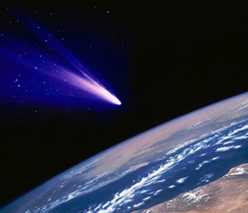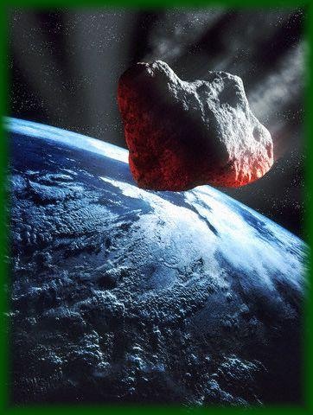
Fig.1 An asteroid approaching the earth at about 15 km/s (relative to the Earth).

IL2 ** Collision with Earth
http://www.valdostamuseum.org/hamsmith/EarthCollisions.html
IL3 *** Impact events discussed
http://en.wikipedia.org/wiki/Impact_event
IL4 *** Picture of large asteroids (see figure 2)
WHERE IS THE INTERNET ADDRESS FOR THIS IL?

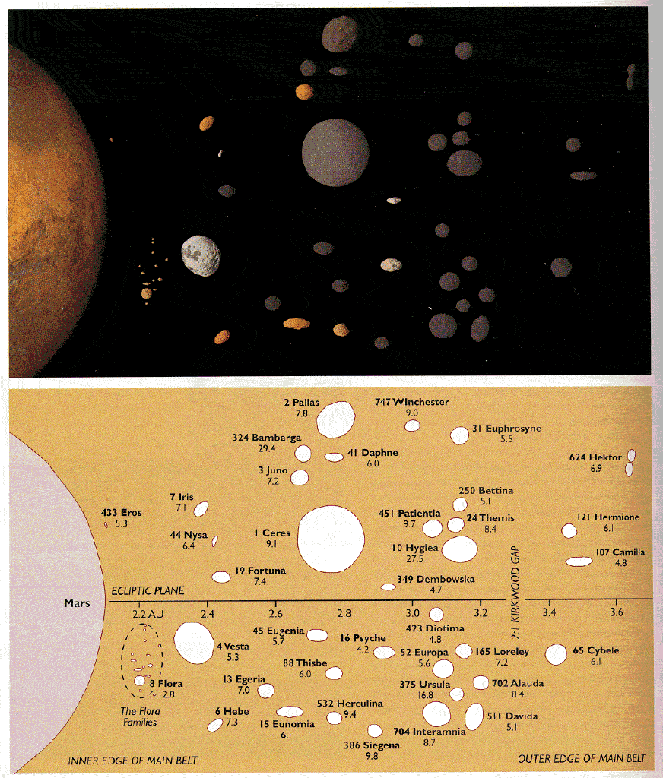
Fig. 2: This representation of asteroids includes most of the asteroids larger than about 200 km in diameter. They are shown in their correct relative sizes and shapes (the limb of Mars is shown for comparison). The bodies are positioned at their correct relative distances from the Sun. Asteroids located near the top or bottom of the diagram occupy relatively eccentric or inclined orbits (or both), while those shown near the ecliptic plane move in relatively circular, non-inclined orbits.

ILV1 **** Asteroid Earth collisions http://video.google.ca/videosearch?hl=en&q=asteroid%20earth%20collisions&um=1&ie=UTF-8&sa=N&tab=wv# (Note: You have to be selective here. Some of the videos are “pure Hollywood” nonsense.)
ILV2 **** Eros http://video.google.ca/videosearch?hl=en&q=travelling%20to%20asteroid%20eros&um=1&ie=UTF-8&sa=N&tab=wv#

IL5 *** The Asteroid Belt
http://www.crystalinks.com/asteroid_belt.jpg

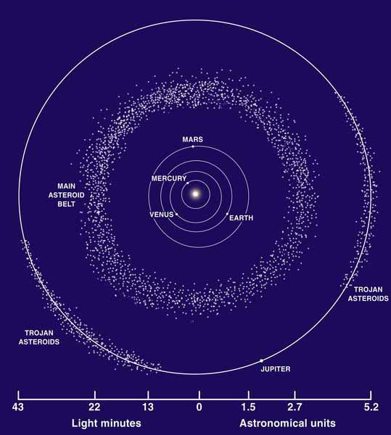
Fig. 3: The asteroid belt is a region of the solar system falling roughly between the planets Mars and Jupiter where the greatest concentration of asteroid orbits can be found. It is termed the main belt when contrasted with other concentrations of minor planets, since these may also be termed asteroid belts.

In this usage, it often refers only to the greatest concentration of bodies with semi-major axes between the 1:4 and 2:1 Kirkwood gaps at 2.06 and 3.27 AU, with eccentricities less than about 0.33, and with inclinations below about 20°.
This region is marked in red in the diagrams below, and contains approximately 93.4% of all numbered minor planets. The asteroid belt region of space also contains some main-belt comets which may have been the source of Earth's water.

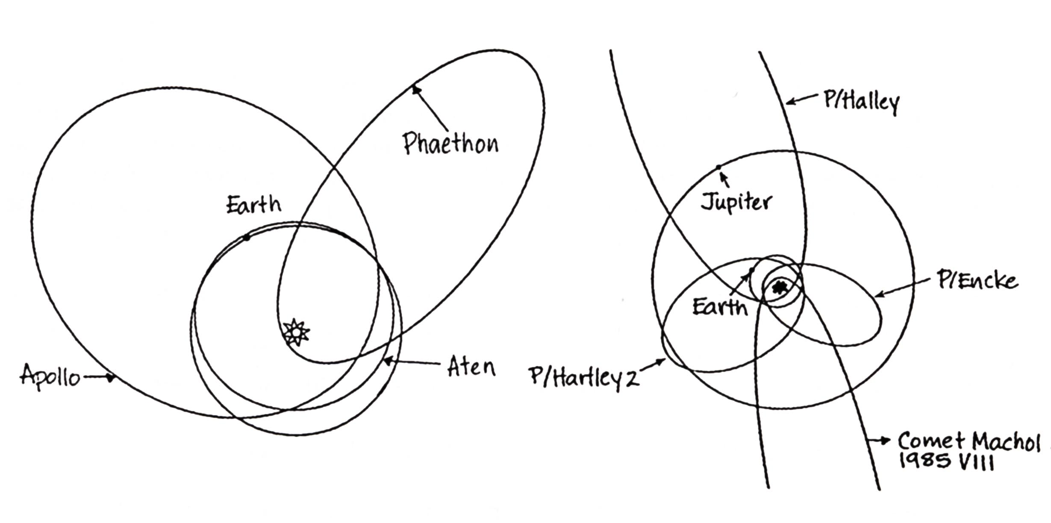
Fig. 4: Earth-crossing asteroids and comets

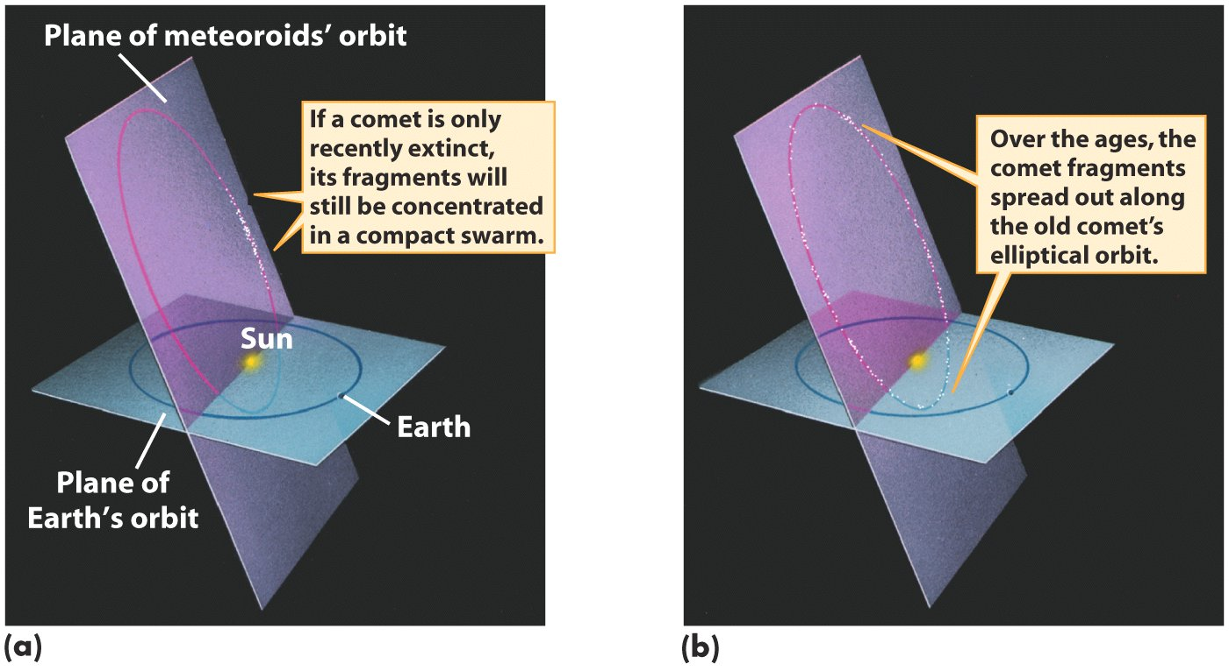
Fig. 5: The plane of an asteroid intersecting with the plane of the earth

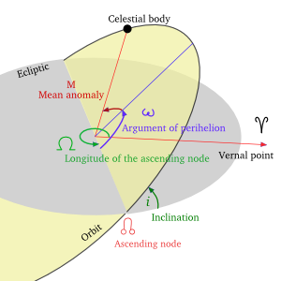
Fig. 6: A diagram of Keplerian orbital elements.

An apsis is the point of greatest or least distance of the elliptical orbit of an astronomical object from its center of attraction, which is generally the center of mass of the system.
The point of closest approach is called the periapsis or pericentre and the point of farthest excursion is called the apoapsis , or apocentre . A straight line drawn through the periapsis and apoapsis is the line of apsides. This is the major axis of the ellipse, the line through the longest part of the ellipse.
Related terms are used to identify the body being orbited. The most common are perigee and apogee, referring to orbits around the Earth, and perihelion and aphelion, referring to orbits around the Sun.

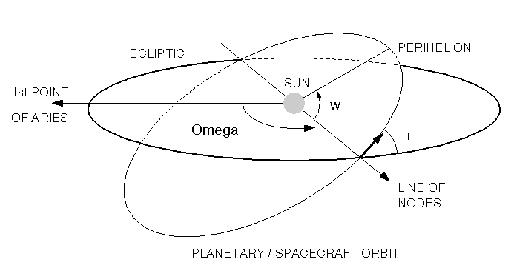
Fig. 7: A planetary spacecraft orbit.

IL6 ** Vernal Equinox
http://www.infoplease.com/spot/riteofspring1.html
ILV3 ** Collision probabilities with Earth
http://video.google.ca/videosearch?hl=en&q=Earth%20crossing%20asteroids&um=1&ie=UTF-8&sa=N&tab=wv# (Note: You have to be selective here. Some of the videos are “pure Hollywood” nonsense)

IL7 ** An example of pseudo-science
http://www.youtube.com/watch?v=jkq5UJn90x0&eurl=http://video.google.ca/videosearch?hl=en&q=Earth%20crossing%20asteroids&um=1&ie=UTF-8&sa=N&tab=wv

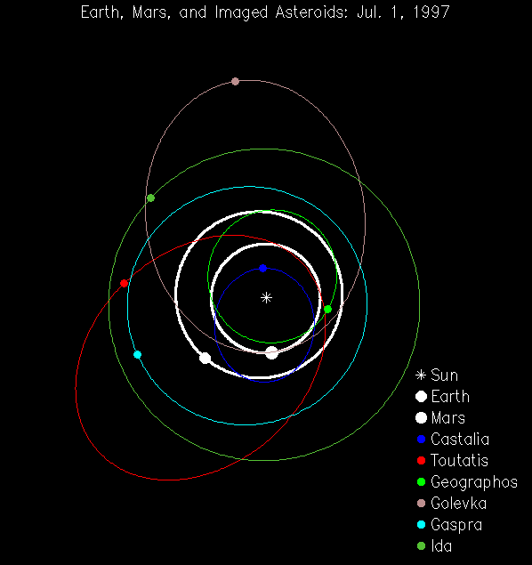
Fig. 8: The orbits of Earth, Mars, and some of the asteroids we will discuss.

IL8 ** A recent (Oct. 2008) “harmless” small asteroid collision
http://en.wikipedia.org/wiki/Tunguska_event
IL9 *** NASA Near Earth Object Program
http://en.wikipedia.org/wiki/Tunguska_event
IL10 *** Pictures of known impact sights
http://www.lpi.usra.edu/publications/slidesets/craters/crater_index.shtml
IL11 *** Recent sighting of an asteroid impact
http://www.eumetsat.int/Home/Main/Media/Features/707785

ILV4 **** A video of an actual asteroid sighted in the sky
http://www.youtube.com/watch?v=9D5fE6QXrpg&eurl=http://www.observatorij.org/News/News.html
IL12 **** Animation showing an asteroid impact
http://en.wikipedia.org/wiki/Image:Chicxulub-animation.gif

The crater that was produced by the asteroid about 60 M years ago in Mexico is more than 180 kilometers (110 mi) in diameter, making the feature one of the largest confirmed impact structures in the world. The impact kicked up incredible amounts of dust into Earths atmosphere at the time, chilling global temperatures and precipitating what many suspect was a nuclear winter-type scenario.

IL13 *** A detailed discussion of the origin of the crater
http://en.wikipedia.org/wiki/Chicxulub_crater
ILV5 **** The Tunguska Event: A science mystery story, still not completely solved. (Make sure that the three videos by Arthur C. Clark are seen before or right after the reading of the text.)
http://video.google.ca/videosearch?hl=en&q=tunguska%20event&um=1&ie=UTF-8&sa=N&tab=wv#
IL 14 *** The Tunguska event (1908)
http://en.wikipedia.org/wiki/Tunguska_event
IL 15 *** The Tunguska event (1908)
http://www.totse.com/en/technology/space_astronomy_nasa/tungusk2.html

Phase I: The mysterious explosion
On June 30, 1908, at 7:14 AM, a mysterious explosion was seen in the skies over Siberia, at latitude 60 degrees, 55 minutes north and longitude 101 degrees, 57 minutes east. You can look this up in an atlas to find that it was one of the most remote places on Earth. The most famous eye-witness account of this event is the one given by S.B. Semenov, who was sitting on the porch of the trading station in the village Vanavara , about 65 km South from the impact area, when he saw what was certainly the most brilliant flash of light ever seen in historical time:
My shirt almost burned off my back. I saw a fireball that covered an enormous part of the sky. I only had a moment to note the size of it. Afterward it became dark, and at the same time I felt an explosion that threw me about twenty feet from the porch. I lost consciousness, and when I came to, I heard a noise that shook the whole house and nearly moved it off its foundation. The glass and the framing of the house shattered...
There are a great many other reports by eyewitnesses of the event. Nearly 700 km to the southwest, the Trans- Siberian Express was wildly jolted, and after sighting the vibrating rails ahead, the engineer brought the train to a screeching halt. Sounds of distant thunder followed. Thousands of kilometers away, in Germany, the United Sates and Java, seismic detectors recorded the events, so that later it was possible to determine not only approximate location of the “explosion” but the exact time of its occurrence. England recorded wild fluctuations in barometric pressure and magnetic disturbances were reported from London. The London Times reported that, on the night of June 30 it was possible to read large print indoors by natural light The report also noted the similarity between this event and the volcanic explosion of Krakatoa, 25 years earlier in 1883. This extraordinary phenomenon of light coming from 10,000 km away, has only lately been explained. By the 1950s the topic of extraterrestrial life had become fashionable and “theories” about the origin of the disaster proliferated.

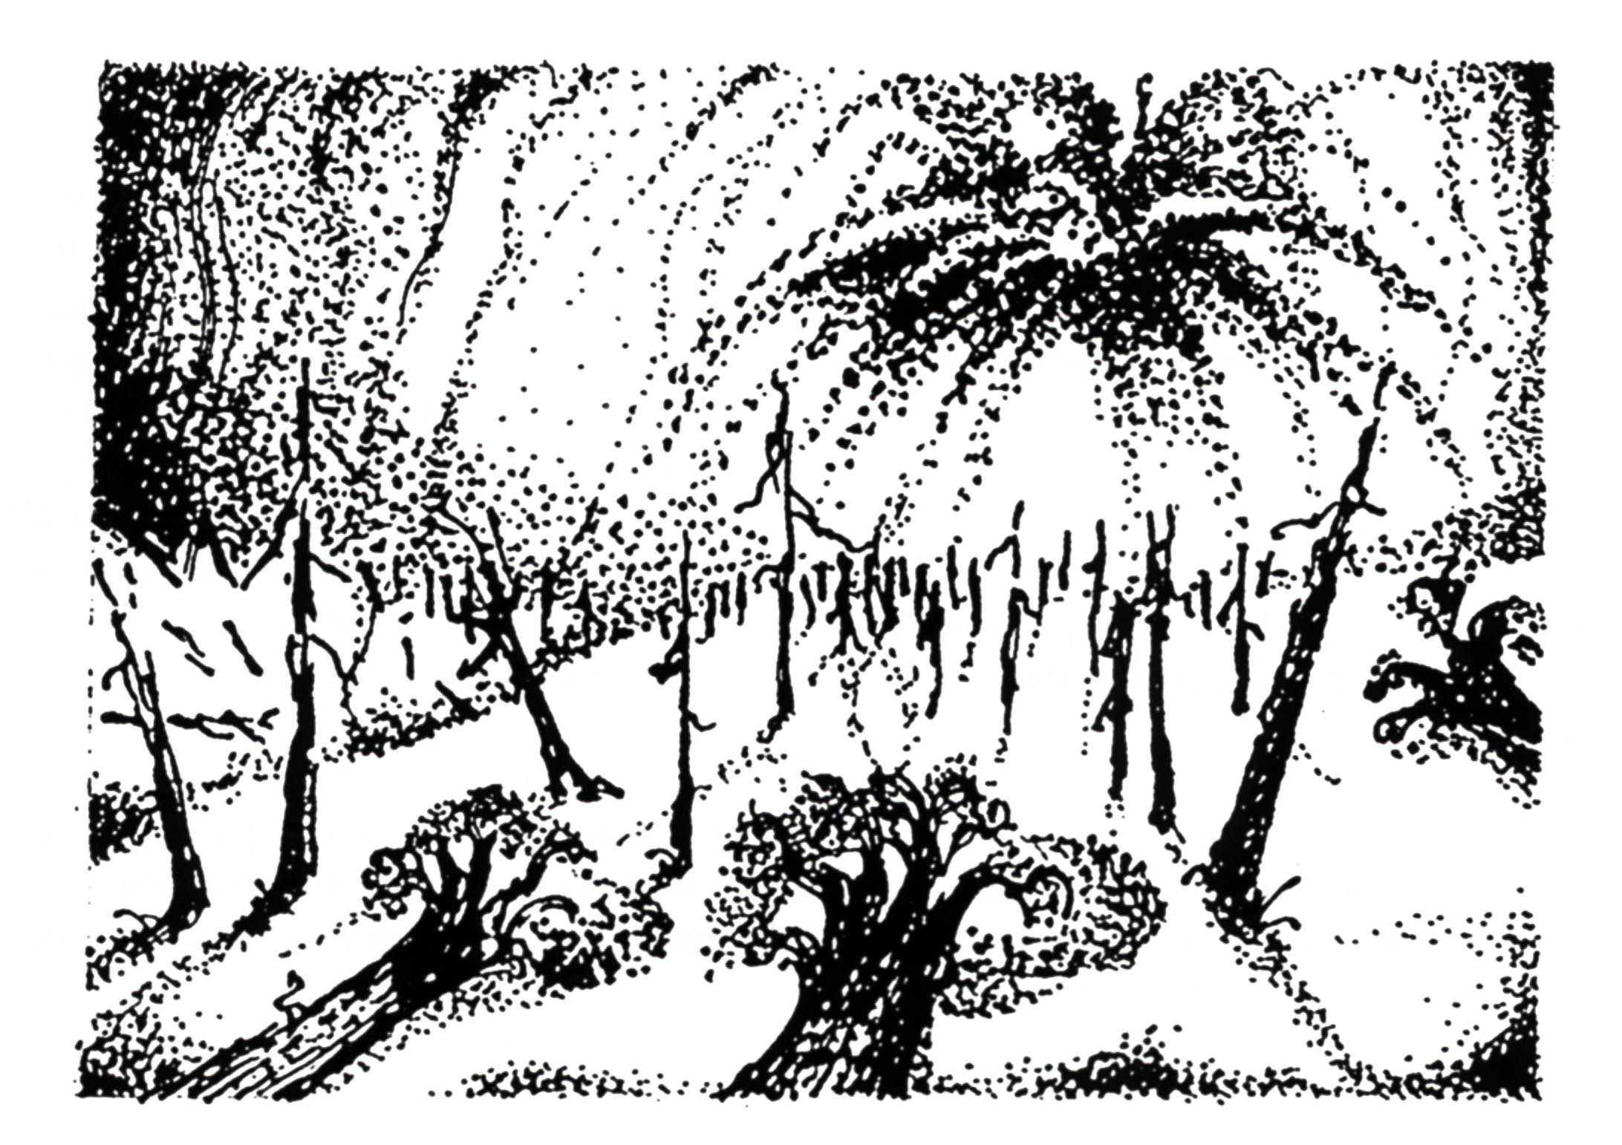
Fig. 9: An artist’s sketch of the Tunguska event.

The Tunguska collision is by far the best example we have of a large body entering the atmosphere in historical times It seems astonishing today that over ten years passed before anyone beyond central Siberia heard about the collision. Unlike the Barringer crater (see figure 25), there is still disagreement regarding what caused the Tunguska explosion. That is, there is still an international debate going on, as you will see below.
It is significant that the descriptions of the event taken from a variety of observers were consistent and it is possible to reconstruct the event, based on these reports. Here then we have another exciting science detective story that is just drawing to a conclusion, after almost 100 years.
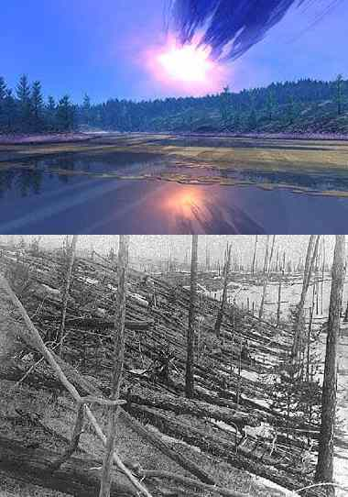
Fig. 10: A mysterious object that exploded high above the Tunguska river in Siberia in 1908 was most likely a stony asteroid about 30 m in diameter, and not, as many thought, a comet. The top picture is a painting and the bottom one a photograph taken about 1927 by the Russian engineer Leonid Kulik

According to the calculations of Christopher Chyba of the NASA Goddard Space Flight Center in Greenbelt, Maryland, only a stony meteorite would explode at an altitude of 10 km the commonly agreed height of the Tunguska blast. A comet would disintegrate much higher in the atmosphere and cause less damage on the ground. We will discus this event in detail.

Phase II: First contact and first guesses
The first scientist to make the journey to Tunguska was Leonid Kulik . Working in the Mineralogical Museum in Petrograd, Russia, he came upon an old Siberian newspaper account of the great event of 1908. Kulik was surprised and puzzled that no scientific investigation had ever taken place. He set out in 1921 with an expedition to Siberia and spent some time in the town of Kansk on the Trans-Siberian Railroad. Collecting eye witness reports he soon realized he was still hundreds of kilometers away from the epicenter of the burst itself.
Based on these contacts, he concluded that
1. the object in the sky was very bright,
2. it moved almost horizontally through the early morning sky from a southerly direction.
3. it was accompanied by loud noise and Earth tremors that culminated in a gigantic explosion near Vanavara, Northern Siberia, and
4. surprisingly, “the noise was considerable, but no stones fell.”
Only in 1927 was Kulik able to mount a second expedition to find the actual site. He now knew that the epicenter lay north of the Tunguska River, but exploring the region promised to be a challenge. That region of Siberia was uninhabited in 1927; there were no roads and he found the area to be a “vast and sinister primeval forest in which the weak and imprudent often perish”. Kulik and an assistant finally arrived at the site after a month of travelling with pack horses and were in a totally exhausted state. They stared in astonishment at the devastation stretching to the horizon before them. Kulik wrote: “The results of even a cursory examination exceeded all the tales of the eyewitnesses and my wildest expectations”.
We must remember that this sighting was made almost 20 years after the explosion. Kulik was sure that not far beyond the horizon he would find a large crater, perhaps thinking of the well known Barringer crater in Arizona. No crater was found.
Over the next 14 years, Kulik led four more Tunguska expeditions. His teams photographed the flattened trees and dragged the swamps for meteorite fragments but found no evidence for these. He was still convinced that a meteorite collision was the cause of the destruction. He died in a Russian prisoner of war camp in 1942.

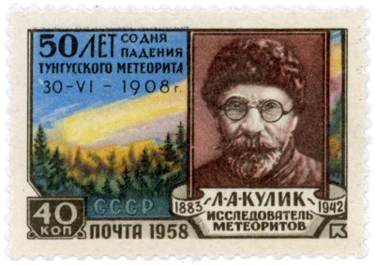
Fig. 11: Leonid Kulik memorial stamp issued in 1958 on the fiftieth anniversary of the Tunguska explosion. The cause of the blast was still very much a mystery when the stamp was issued.

Phase III: Russian scientists close in on the mystery
Alexander Kazantzev, a soviet engineer and army colonel, wrote a short story just after the Second World War, in 1946, in which he argued that only a nuclear explosion could have caused the bizarre wreckage at Tunguska. This is a very timely idea that was suggested right after the first nuclear bombs were exploded in Japan in August of 1945. He argued that, since there was no nuclear capability in 1908, the destruction must have been caused by an exploding space ship. The story captured the imagination of the public and was reprinted in 1958 it became a very popular book called Guest from Space. A new generation of scientists in Siberia was intrigued and argued that there should still be measurable levels of radioactivity in the region of the explosion. One of those young scientists was Victor Zhuravlyov, now a physicist stationed in Tomsk, Siberia. Another physicist in Tomsk, Gennady Plekhanov, believed that “In a year or two the Tunguska problem would be solved”.
The Russian physicists were wrong. Plekhanov led two expeditions to Tunguska, one in 1959 and the other in 1960, looking for evidence of significantly elevated radiation levels and scouring the site for meteorite fragments. They found neither. Plekhanov later said: “We then realized that the situation was far more complicated than we had thought”. In 1963 he gave a report to a crowded assembly at one of Russia’s top scientific institutes. Despite the negative results of the expedition, he received a very warm reception from other scientists.
Since 1963 Russian scientists have visited Tunguska every summer, collecting a huge amount of data. They mapped out the pattern of fallen trees in great detail, painstakingly covering the entire 2100 square kilometer area of the destroyed region. This time-consuming survey paid off when other scientists and mathematicians were able to use these data and conclude that “the trees must have been knocked down by a blast about 7 km above the ground with energy of 10 - 20 megatons of TNT as the object travelled an east-to-west-course.”
For 30 years the investigation of the Tunguska mystery remained exclusively in the Russian scientific domain. This is not surprising since Tomsk was a center of research into military technology and was closed to foreigners during the ‘cold war’ years .

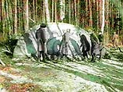
Fig. 12: Researchers in Tunguska. Members of the scientific expedition of the Siberian state foundation Tunguska Space Phenomenon have managed to uncover blocks of an extraterrestrial technical device, which crashed down on Earth on June 30th, 1908. In addition, expedition members found the so-called "deer" - the stone, which Tunguska eyewitnesses repeatedly mentioned in their stories. Explorers delivered a 50-kilogram piece of the stone to the city of Krasnoyarsk to be studied and analyzed.

Phase IV: Italian and American physicists join the search
By the end of the “cold war”, in 1989, outside researchers were allowed to visit and study the site. The Italian physicist Menotti Galli, after studying cosmic radiation for 40 years, became interested in the Tunguska Event mystery. Based on his work showing that high energy particles from space can add heavy isotopes of carbon to the cellulose in trees, he argued that if there were high energy particles involved in the collision, isotopes of carbon should be found in the cellulose in trees. Perhaps the answer to the mystery lay in the annual growth rings.
Galli was able to acquire a chunk of Tunguska spruce taken during the 1990 expedition. It turned out that the piece of wood was not good enough for the study of rings because a dead branch had been enveloped by the growing trunk decades ago, spoiling the annual pattern of concentric rings. Suddenly, Galli realized that this could be a serendipitous event for him: the tree had build resin around the branch in order to protect its living tissue from infection He reasoned that if the bolide (a collective term used for all meteors, comets, and asteroids) had showered any particles into the forest upon impact, they would have been trapped in the resin and might still be intact. Galli thought that the candidates for the bolide that caused the devastation were these:
1. A fragment of a comet. This is generally considered to be a “a dirty ball of ice”, born in the earliest stages of the solar system, which wandered from time to time from its home beyond Pluto to the neighbourhood of Earth.
2. A meteorite. These are battered remnants of asteroids, which themselves are wreckage of failed planets. There are stony meteorites, some rich in carbon called carbonaceous chondrites, and others are rich in iron.
Galli’s work intrigued his colleague, the physicist Giuseppe Longo. He was a theoretical physicist for almost 40 years who saw in the Tunguska Event a welcome change from his work that dealt with the mathematics of particle interaction in nuclear physics. Galli and Longo decided to begin their attempt to solve the mystery by testing a new hypothesis by American scientists that was developed in the 1970s but never followed pursued.
The American scientists argued that if a comet exploded over Tunguska the signature of that comet might be recognizable. The hydrogen contained within the comet would have been compressed and heated as it encountered the atmosphere at a great speed. The pressure and the temperature might have been high enough to satisfy the conditions for a small thermonuclear reaction, or fusion. Some of the hydrogen then might have fused into helium, triggering an H-bomb-like explosion. A few milligrams of fused hydrogen would be enough to produce trillions of high energy neutrons and these could in turn combine with nitrogen atoms in the atmosphere, producing carbon 14 isotopes. They looked for carbon 14 in the tree rings but could find none. This finding did not entirely eliminate the comet hypothesis, but it made it less likely.

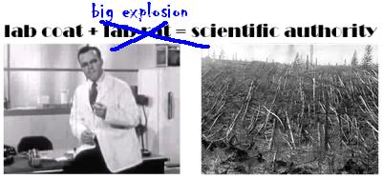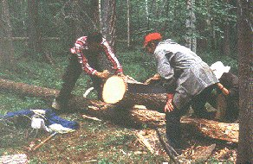
Fig. 13: When Menotti Galli visited Russia he learned that the trees picked up “unusually high levels of elements like copper, gold, and nickel”. He said: “I am fairly sure this only applies to trees around in 1908 which got showered with bits of exploding rock”.

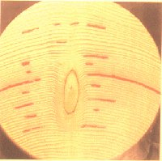
Fig. 14: Sawing a radial sample of the tree in whose resin the first particles linked to Tunguska body have been identified. K. Korlevic (left). Below: A node of Siberian pine, surrounded by resin, in which the first particles of several microns in size have been found. Longer, red line is the year 1900, and in the 1908 line a visible wood tissue trauma exists. Photo by Menotti Galli.

Galli and Longo now turned to testing the resin. Unfortunately, they were unable to accurately date the resin from their single sample of spruce. They joined the 1991 expedition to Siberia and flew by helicopter to the isolated camp near Vanavara that was put up by Kulik 64 years earlier. They found the camping and the hunt for candidate trees difficult and exhausting. Dozens of pines had survived the blast, but this species produces little resin. After many weeks of tedious searching, the Italian researchers managed to find six spruces in an 8 km radius that survived the blast. For a control they also took with them samples from the nearby city of Tomsk. They went back to Italy with 13 good samples that contained resin.
In analyzing the samples they used a scanning electron microscope, with an attached an energy dispersive x-ray spectrometer. Over the next two years the researchers gathered some 6000 particles from the resin and compared these with the results obtained from the Tomsk spruces. Unfortunately, they were unable to date the resin samples closer than a period of 10 years. Nevertheless, they found significant evidence that in the layer which included the year 1908, unusually high levels of certain elements, especially copper, gold, and nickel were found , elements whose atoms contain a high number of protons. Did these particles, in which high levels of these elements occur, have an extra-terrestrial origin?
Meanwhile other American researchers were making computer simulations of the Tunguska event. One of the models that attracted attention was the one tested by planetary scientist Chris Chyba and his collaborators. They developed a model that describes the dynamics and structure of comets and asteroids of various types (carbonaceous, iron, stone) as they move through the atmosphere at hypersonic speeds (15-35 km/s). Other American researchers lead by Kevin Zahnle studied what happens when a bolide hits the ground or disintegrates in the atmosphere. These groups then combined their expertise to simulate the Tunguska event. This is what they found:
1. Small bolides burn up quickly in the atmosphere; large bodies reach the ground.
2. Bodies between about 1m and 10m, burn up entirely, or only partially, depending on the type of material of which it is composed. Carbonaceous asteroids burn up; iron burns only partially.
3. When a midsize bolide (between 30 and 100 meters across) rips through the atmosphere, the intense pressure exerted by the air deforms the rock and spreads it out like pancake. There is almost no force on the back of the bolide so the differential forces tear the bolide apart. The fragments themselves are subjected to the same forces, and so on. In a fraction of a second this process turns the bolide into a cloud of debris, as if dynamited in midair.
4. Asteroids larger than 100 m, those that are 1 km or more do not “see” the atmosphere. They collide with the atmosphere at high velocities and reach the ground in a few seconds, losing very little speed.
5. What at first seems to be a mystery (great explosion at high altitude followed by devastation of large area, but no trace of a meteoritic material) turns out to be just the typical fate of stony asteroids with a diameter between about 50m to 100 m and entering the atmosphere at common hypersonic speeds of 15-25 km/s.

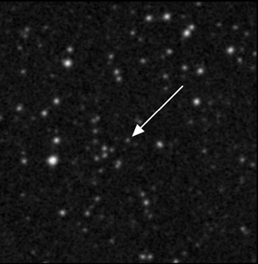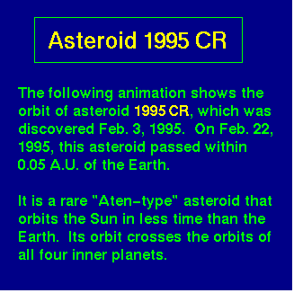
Fig. 15: Earth-crossing asteroid

IL16 **** Applet showing motion of Asteroid 1995 CR
http://csep10.phys.utk.edu/astr161/lect/asteroids/animation/asteroid_anim.gif

How can we use these theoretical results and apply them to what happened in Siberia? What data did the researchers have that can be used in testing this model? They could only guess the size of the bolide, and did not know what it contained; ice, stone, or iron. Moreover, they had no data on the speed or entry angle. Eyewitness accounts suggested 5 to 17 degrees, while tree fall patterns pointed to a much steeper angle, between 30 and 40 degrees.
How can we use these theoretical results and apply them to what happened in Siberia? What data did the researchers have that can be used in testing this model? They could only guess the size of the bolide, and did not know what it contained; ice, stone, or iron. Moreover, they had no data on the speed or entry angle. Eyewitness accounts suggested 5 to 17 degrees, while tree fall patterns pointed to a much steeper angle, between 30 and 40 degrees.
Faced with the lack of data, the researchers imagined a number of plausible situations (models). They found that iron bolides were too strong and too dense; they would slam into the surface of the Earth. Comets, on the other hand were so delicate that they exploded at a height of 23 km, too high to match the Russian calculations from tree fall patterns. Carbon-rich carbonaceous chondrites entering the atmosphere at 45 degrees would blow apart at a height of 15 km, 7 km too high.
But a heavy 60 m stony meteorite, falling to Earth at 45 degrees would explode at about 8 km, which was the right height. The researchers were delighted when they found that this model could also explain the mysterious “night lights” that followed the event, seen as far away as England! The model suggested that the force of the blast lifted the dust into the upper atmosphere, high enough so that the sun’s light could be reflected long after it had set.

Phase V: More challenges from other researchers
Jack Hills and Patrick Goda, two other American researchers found that it is possible to fit a meteorite to the Tunguska event. They found that about 90% of a meteorite would burn up but about 10% would have sprinkled down onto a mere couple of square kilometers of forest as fine gravel. It is therefore understandable, they argued, why no large chunks have been found. The Italian researcher Longo found earlier that there was actually evidence of heavier particle concentration in trees in the middle of the crash area. Commenting on the Hills model Longo said: “If a lot of debris fell into the Southern Swamp, it would be extremely difficult to find fragments 20 years after the explosion”
Two more American researchers, Evans Lyne and Richard Fought, challenged a basic assumption that both Chyba and Hills made in their models. They assumed that as a bolide fell through the atmosphere, it would heat the air in front of it to about 25000 degrees Kelvin, and most of the great heat involved would get transferred to the bolide and burn it away. They argued, that the layer of air directly in front of the falling bolide would heat up and the glowing gas radiate heat away from the bolide. This meant that significantly less heat would be transferred and less of the mass burned up, so that it can get closer to the Earth before it explodes. They then argued that carbonaceous chondrites, which Chyba had ruled out, explode at the right height, after all!
Despite an apparent confrontation between the American researchers, there seems to be a friendly rivalry between them. Lyne has noted that simulations of this kind create a “lot of wiggle room” - even a comet could have exploded low enough if it had come in at a sufficiently steep angle. As he said: “Any type of body can be pinned down”, as bolide responsible for the event.

Last Phase? Meanwhile Russian scientists cling to their hypothesis...
Many Russian scientists have been wrestling with the Tunguska event for decades and they view the American efforts with some scepticism. Many cling to the idea that it was a comet that crashed into the tundra. They still consider the eyewitness reports on the angle of entry as a strong indication that the bolide came from cometary debris known as Taurid shower, through which the Earth happens to pass every June and November. Another reason why for many Russian scientists the asteroid hypothesis is unacceptable is that they have searched the site for meteorites every year for decades and have found no remnant of such objects.
As one leading Russian astronomer, Vitaly Bronshten, put it: “The lack of this ‘smoking gun’ supports the cometary hypothesis.” And another (American) astronomer, Nina Fast, said jokingly, referring to the “fun” scientists have with this 90 year-old puzzlement: “If we found a meteorite, we would bury it...we enjoy the paradoxes and the contradictions”.

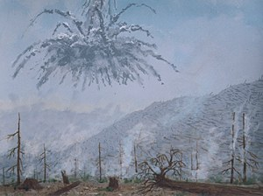
Fig. 16: View from Kirensk, Siberia, seconds before the explosion and then at the time of the explosion at Tunguska. Paintings by the astronomer William K. Hartmann

IL17 *** More recent theories about Tunguska
http://www.bibliotecapleyades.net/ciencia/esp_ciencia_tunguska17.htm

Exotic theories about Tunguska
Between 1946 (just after the end of World War II) and about 1975, exotic hypotheses proliferated about the origin of the Tunguska Event, especially since there was no crater and no remnants of a comet or asteroid found. These hypotheses were clearly guided by the new ideas in science that emerged after the second World War, , such as nuclear energy, antimatter, and black holes, not to mention the UFO phenomenon that took the 1950s by storm.
None of these hypotheses are now taken seriously but it is interesting to discuss them, especially in a science class room:
1946 Nuclear energy from space: A nuclear powered alien spacecraft spinning out of control crashes into the Earth
1954 A flying saucer exploded.
1965 Antimatter meets matter. Willard Libby, a distinguished scientist suggested that the explosion was the result of antimatter from space colliding with matter (air).
1973 A mini black hole crashes into the atmosphere. A mini black hole hit the Earth in Siberia, then passing on through the Earth and out the other side.

IL17 *** Recent hypotheses about the cause of the Tunguske event.
http://www.physorg.com/news819.html

We read the following from the above IL17.

The precise cause of the Tunguska event remains unknown. In scientific circles, the leading explanation for the blast is the impact of a meteorite. A related suggestion is that a meteorite exploded just above the Earth's surface. Whether the meteorite was of cometary or asteroidal origin is still a matter of controversy. Whatever the original cause of the event is, much of the data supports that the cause resembled a nuclear explosion.
In the absence of an obvious explanation, numerous alternative theories have been offered, such as a small black hole passing through the Earth, an impact from a piece of antimatter, and even the catastrophic destruction of a nuclear-powered alien spacecraft. However, there has not been much evidence for these exotic ideas, and simpler theories are available.
The new theory suggests that the event was a collision of a meteorite with an alien spaceship. “They exploded this enormous meteorite that headed towards us with enormous speed,” Yuri Lavbin said. Now this great object that caused the meteorite to explode is found at last. We will continue our research, he said.
The final word?

We will conclude this science story of competing models and hypotheses to explain the Tunguska event with one that is considered the most thorough investigation, according to many leading Western researchers. In 1983, Zdenek Sekanina, a scientist at the Jet Propulsion Laboratory in California, published an exhaustive study of the evidence surrounding the Tunguska Event. Sekanina concluded at the end of his paper (see References):
1. The object came in from a direction close to 110 degrees east of north at a speed of about 30 km/s.
2. It exploded at an altitude of about 8.5 km.
3. It experienced pressures of several mega atmospheres.
4. The explosion itself produced light that was as bright as 40 times the brilliance of the noonday sun. (in spite of the fact that eyewitness reports said that it was fainter than the sun)
5. About a billion kilograms of material was dissipated in less than one tenth of a second.
6. This energy was equivalent to the energy release of the first nuclear bombs.
7. The energy released was enough to wipe out New York City.
8. The velocity vector (the direction of entry) leads to a solar system orbit that rules out a comet.
9. The object was most likely a small asteroid about 100 meters across.
10. The object was of a stony material, not iron.

It is sobering to realize that, had the Tunguska object arrived at the Earth only a few hours later, the Earth’s rotation would have had brought the collision in to more densely populated areas, perhaps even major cities, such as London or New York. Hills and Goda, for example, have calculated that impact from an object of about 400 meters across “anywhere in the Atlantic would devastate coastal areas on both sides of the ocean”. The tidal wave (tsunami) would reach heights of 200 meters and hit the coast with a pulse duration of several minutes.
It has been suggested that the legendary Atlantis, which was said to be located on the Atlantic coast in Western Europe engulfed suddenly by a tidal wave. It is puzzling that there were no settlements along the Atlantic until after 800 C.E., when the Vikings settled and fortified towns along the coast. It is comforting to know that these catastrophic events occur very seldom. Sekanina thinks that events like the Tunguska collision probably occur only once every 10,000 years or so.
The bolide now thought to have caused the devastation at Tunguska, Siberia, on June 30, 1908 was believed to be of the order of 100 m across and exploded in the atmosphere. In contrast, a metallic asteroid of similar size formed a crater 1.2 km in diameter in Barringer Arizona some 50,000 years ago.
And still the question of the exact nature of the impactor at Tunguska is debated. The astronomer Duncan Steel argues that scientists that specialize in the physics of impacting bolides have a good knowledge of the dynamics of small meteorite collisions of up to about 10 meters and those above 100 meters, but the dynamics of the 10 to 100 m ones are not well understood. He points out that the models that convinced the Americans that the impactor was 100 m rock asteroid, studied by Chyba and his colleagues, were very simple, and even simplistic, and may not tell us much about how real asteroids of that size behave upon impact at hypersonic speeds. Steel points out that for the models Chyba used he assumed a spherical shape, a homogeneous structure, whereas real asteroids are shaped like large boulders. They often spin wildly and their composition is a mixture of sand, rock and metal. He also reminds us that we are essentially ignorant of the physical strengths (tensile strength) of asteroids and especially of comets. Steel concludes that the Russians might still be right: it may have been a comet, coming in at a speed of more than 30 km/s that caused the Tunguska event.
Chyba and his associates, of course, strongly disagree. They believe that their model is consistent with the Tunguska explosion, the meteor crater in Arizona, and the Revelstoke object (to be mentioned later), provided that the bolides that caused them were stony, iron, and carbonaceous asteroids respectively. They argue that had a 15 megaton comet exploded, far less destruction would have taken place, because the explosion would have occurred at a much higher altitude. It is well known that comets of tens of kilotons of energy explode so high in the atmosphere that we do not even notice them on the surface.

Questions
1. At the trading station in Vanavara, Semonov claimed that he was unconscious between the moment he saw the brilliant flash in the sky and when he heard the “noise that shook the whole house”. Based on this report, approximately how long was he unconscious?
2. Form groups for the various “theories” to explain the Tunguska Event. Include the exotic ones, such as the passage of a black hole through the atmosphere. Debate these theories.
3. Recent reconstruction of the event and estimates of the energy involved based on seismographic records, extent of forest destruction, and contemporary barometric readings places the energy at about 10 to 20 M tons of TNT.
a. Show that this kind of energy would be associated with a 50-100 meter asteroid entering the atmosphere with a speed of about 15-20 km per second.
b. If you tried to defend the nuclear fission hypothesis, what size of nuclear explosion would be involved? c. If you tried to defend the thermonuclear (fusion) hypothesis, how much matter-antimatter would have to combine to produce this explosion?

Problems
1. It is estimated that the explosion in Tunguska felled about 40,000 trees over an area of 2200 km². Estimate the energy needed to accomplish this. Take the average tree to be about 30 cm diameter.
2. The estimated size of the stony asteroid was about 50 m across, entering with a velocity of about 15 km/s. Calculate the kinetic energy of this bolide. Later, you can use our model to answer other “what if?” questions.

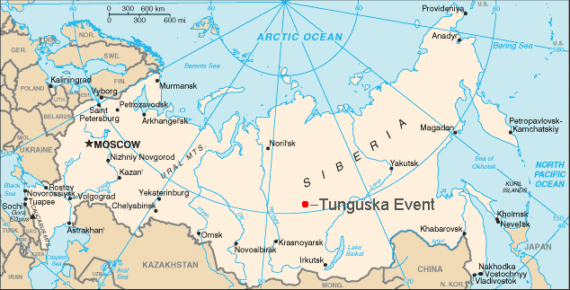
Fig. 17: Approximate location of the Tunguska event, in Siberia.

Preliminary calculations for the Tunguska Event: Preparing for the design of a model
The prominent astrobiologist Christopher Chyba and his associates at the Space Science Division of NASA recognized that the solution of the long-standing puzzle of the Tungaska collision lay in developing a realistic model of the atmospheric entry of small bodies. The puzzle, of course, was connected with the sudden tremendous explosion at a height of about 8 km that was seen, heard, and felt from hundreds of kilometers away
The astronomers knew that the physics of small meteorites was well known, and for the large bodies of 1 km and up, the atmosphere does not present a great barrier. They come through without a significant loss in speed, suffering very little deceleration on the way down. These large bodies do not explode even when encountering the high density at about 10 km. The main reason for this is that the shock waves produced when the body meets the denser part of the atmosphere do not have enough time to cross the body before it reaches the ground. The problem is that we do not know enough about the speed of shock waves in these bodies because their density and composition is largely unknown
The very small particles (the size of dust, 10⁻⁶ to 10⁻⁴ m) decelerate slowly and reach the ground intact; the larger particles, from about 1 mm grains to 1-2 meter boulders, burn up and little or no solid material is left; and those above 100 m and larger reach the ground virtually at the same speed as their entry speed into the atmosphere. Poorly understood are the bodies between about 10m and 100m diameter. These are the bodies that require more research in order to understand what happens to them when they enter the atmosphere at hypersonic speeds. The most important factor that determines how they detonate and at what height is the strength of cometary and asteroid materials. In addition, the density and the composition of the body will determine the speed of the shock waves produced.


Fig. 18: Professor Chyba

IL 18 *** Prof. Chyba in conversation
http://www.seti-inst.edu/news/voices/chyba-123102.php

We are now ready to do some elementary calculations that will lead us to describe a simple model in order to understand what happened at Tunguska in 1908. First, we assume that the object is a cube and has a uniform composition. In reality, of course asteroids are irregular, often shaped like a potato or a peanut, and often rotate wildly. Secondly, we must know the velocity with which the body has entered the atmosphere. Finally, we must be able to calculate the force acting on an object as it falls through the air as a function of the velocity of the object, knowing the density of the air, the size of the object, and the mass of the object.
These are the independent variables. The dependent variable here is the drag force. You should now look at the section in LCP2 where we discussed the drag forces on cars and the terminal velocities of falling objects. There we used the proportionality relationship.
Drag force is proportional to density of the air times the square of the velocity times the area of exposure in the direction of the motion, or:
F_{D} ~ d . v² . A
Introducing a proportionality constant k we can write:
F_{D} = k d v² A C_{D}.
It turns out that k = ½ C_{D},
so that F_{D} = - ½ d v² A C_{D}
The minus sign reminds us that this is a retarding force.
This equation applies to a car moving at a high speed as well as to a bullet moving at speeds, an order of magnitude higher. It applies in a limited way, as a first approximation, to an asteroid or comet moving through the atmosphere at hypersonic speeds. The drag coefficient for a truck is about 0.8, for a car about 0.5, and for a bullet about 0.1.
We will choose 1.5 as the drag coefficient for an asteroid, following the work of the astronomers Chyba and his colleagues, to be discussed below. Notice that the units for the density d must be in kg/m³, velocity in m/s, area in m². What, then, are the units (dimension) of C_{D}?
We will now use these equations to obtain approximate answers for the asteroid, like the one in Tunguska, falling through the atmosphere at a hypersonic speed.
A more complete analysis of the problem will be undertaken below when we use spread sheets. We still would not know the mass of the asteroid to a high degree of accuracy, or the strength of the material that holds the asteroid together. This simple approach, however, turns out to be quite adequate for what scientists call a “first order” approximation before they develop a better model. See the sketch, showing the forces acting on a bolide as it enters the atmosphere, in the next section.
Below is a table that shows the variation of atmospheric density with height. You will need this table to calculate the average drag force on a bolide as it falls through the atmosphere. Note that in these simple calculations we
a. use the kinematic equations of uniformly accelerated motion
b. assume that the density of the atmosphere changes linearly within every 10 kmsegment.
c. calculate average accelerations, a_{av}
d. apply Newton’s second law of motion as F_{av} = m a_{av}

Table 5: Atmospheric density and the height above ground (sea level)
Height (km) | Density kg/m³ | Height | Density | Height | Density
Ground | 1.225 | 9 | 0.4671 | 45 | 0.0020  2.0x10⁻³
1 | 1.1117 | 10 | 0.4140 | 50 | 0.0010  1.0x10⁻³
2 | 1.0066 | 11 | 0.365 | 60 | 0.000306  3.06x10⁻⁴
3 | 0.9092 | 15 | 0.1948 | 70 | 0.000088  8.8x10⁻⁵
4 | 0.819 | 20 | 0.0889 | 80 | 0.000020  2.0x10⁻⁵
5 | 0.7364 | 25 | 0.040 | 90 | 0.000003  3x10⁻⁶
6 | 0.6601 | 30 | 0.0184 | 100 | 0.000001  1x10⁻⁶
7 | 0.5900 | 35 | 0.008 | 110 | 0.0000003  3x10⁻⁷
8 | 0.5258 | 40 | 0.0040 | 120 | 0.00000003  3x10⁻⁸

You should now plot a graph of this important relationship for future use. Is this really a linear relationship? Guess the algebraic representation of it; is it of the form d = h^{n}?

Problems
The following problems will show you how to calculate the values to complete Table 6 below:
1. Find the average drag force on the asteroid in the first 50, 000 meters
2. Calculate the deceleration effect of this force and show that it is very small.
3. What will be the velocity of the asteroid as it reaches the 50,000 meters level? Does your answer surprise you? Explain.
4. In what time would the asteroid fall to this height?
5. Find the average drag force on the asteroid as it descends from 50,000 m to the ground.
6. Calculate the average deceleration due to the drag force.
7. You can now estimate the velocity of the asteroid just before it collides with the Earth, assuming that it does not shatter.
8. Estimate the force and pressure acting on the surface just before impact. Express this force in terms of number of g’s and the pressure in terms of atmospheres. Comment.
9. The Tunguska bolide exploded at a height of about 8.5 km. Stony asteroids may shatter when the so- called yield strength is about 1x10⁷ N/ m². In other words, when this pressure on the area of the stony asteroid descending is reached, it will explode. Note: You may find that according to our simple model the height at which this will occur is more like 10 km, rather than 8 1/2 km.

Table 6:
Height  (10³ m) | Average density (kg/m³⁾ | Drag Force (N) | Acceleration,  due to drag (m/s²) | Acceleration  m/s² | Velocity  m/s
100
90
80
70
60
50
40
30
20
10
Ground

Description of the bolide:
Diameter of bolide: 100 m
Volume: approximately 1x10⁹ m³
Density of bolide: 3x10³ kg/m³
Mass of the bolide: 3x 10⁹ kg., or 3000 megatons

Other interesting questions
1. What is the gravity at 100 km height if the gravity on the ground is considered about 10m/s².
2. Where, approximately, was the drag force equal to the weight?
3. Approximately how much energy (expressed as a percentage) was lost in coming through the atmosphere, assuming the asteroid impacts the ground intact?
4. Compare this collision with the Hiroshima nuclear explosion (about 15 kiloton TNT equivalent).
The conclusions we can draw for a head-on collision with a 100m (or larger) asteroid, coming in at the top of the atmosphere at a very high speed are these:
1. The impact velocity will be only a little lower than the entrance velocity.
2. The drag force acting on the asteroid during the first 50,000 m will be small and the asteroid actually speeds up!
3. The forces acting on the 100 m asteroid between 10,000 m and the ground will reach several hundred g’s and the pressure against the attacking surface will be millions of atmospheres.
4. The time of descent is approximately 100 km divided by the entrance velocity, which is for the case of 20 km/s only about 5 seconds!

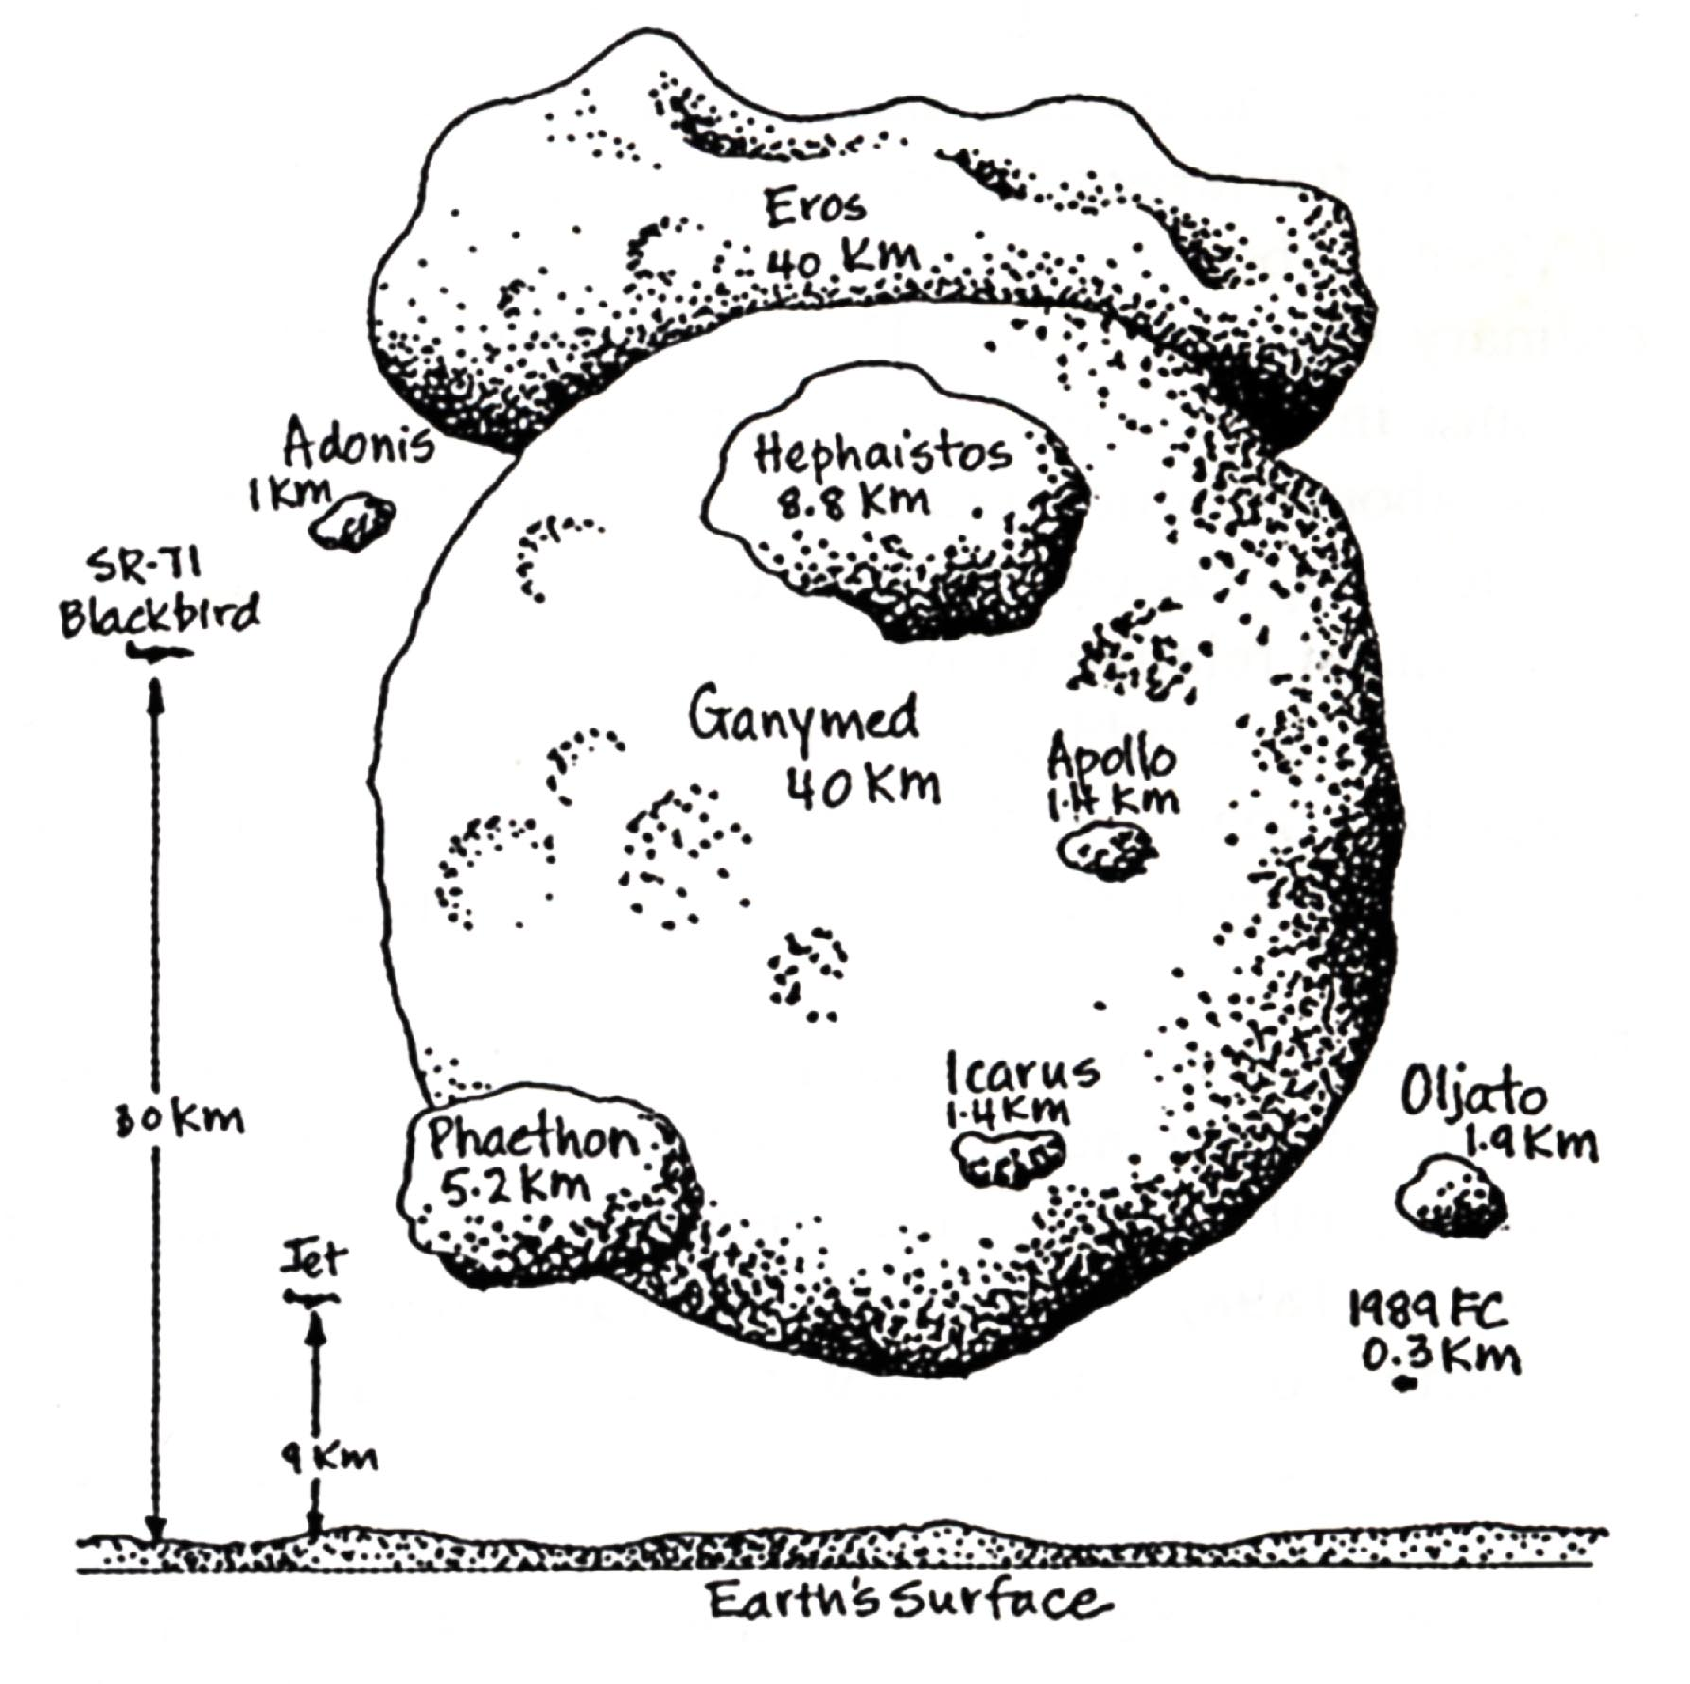
Fig. 19: Sizes of near-Earth asteroids

Modelling the Tunguska event
You should now go back the section Preliminary Calculations” to get reacquainted with the assumption we made about asteroid and comets entering the Earth’s atmosphere. For example, the assumption that an asteroid is a cube turns out to be adequate for, what physicists call a “first-order” approximation before they develop a better model. The following is partly taken from the article: “Deep Impact: The Physics of Asteroid/Earth Collisions”, by Donald Metz and Arthur Stinner, in November 2002 issue of The Physics Teacher. See IL1.
Astronomers like Christopher Chyba and his associates at the Space Science Division of NASA recognized that the solution of the long-standing puzzle of the Tunguska collision lay in developing a realistic model of the atmospheric entry of small bodies. The puzzle, of course, was connected with the sudden tremendous explosion at a height of about 8 km that was seen, heard, and felt from hundreds of kilometres away. We are now in the position to study a simple model based on Chyba’s hypothesis for the collision between meteorites and the earth. Our concern is this: “What if” an asteroid or comet fell to the Earth? Will it burn up, will it explode, or will it pass through the atmosphere to create a huge explosion, a crater lake, or even worse, an extinction event? We have already discussed the fact that the answer depends on several factors. The electronic spreadsheet is an ideal tool to quantify the “what if” question for a number a varying factors.
Table 1 illustrates how you can build a spreadsheet program to model the asteroid event. Rows A to E represent the initial conditions of our asteroid and rows G to M represent the calculations we must make for a typical example. In rows E and M we have generically coded the formulae that must be entered in those cells and the symbols used in the formulae are bolded in the column headings. Rows N to S depict some sample calculations for our example. For a quick start, if you do not wish to build your own spreadsheet, you can download a sample spreadsheet (in Quattro Pro format) from my website at www.uwinnipeg.ca/~metz. Also see the spreadsheet at the end of this LCP.
First, we assume that the object is a cube and has a uniform composition. In reality, of course, asteroids are irregular, often shaped like a potato or a peanut, and often rotate wildly. However, the assumption that the asteroid is a cube turns out to be quite adequate for what scientists call a “first order” approximation before they develop a better model. Later, we will show how to modify this option to approach a “more realistic” model.

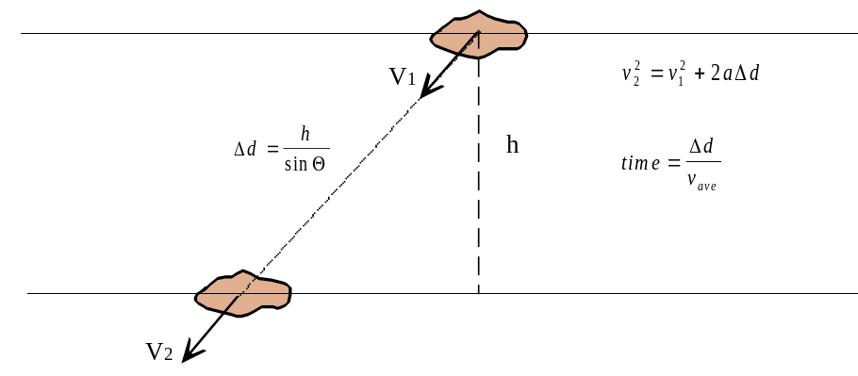
Fig. 20: The Asteroid passes through one interval.

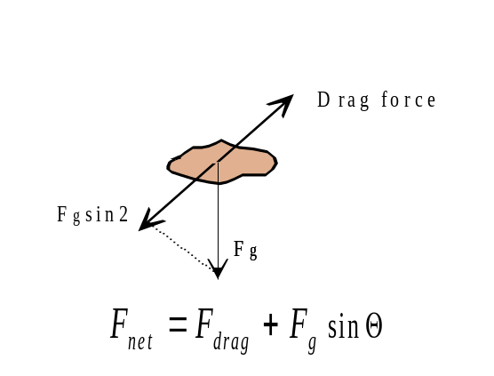
Fig. 21: Forces diagram
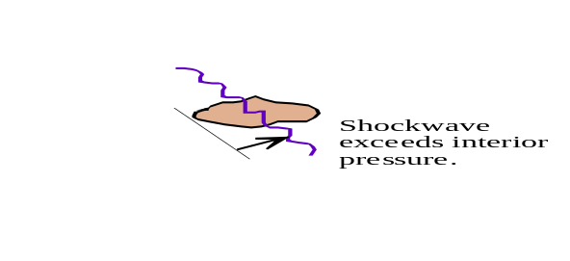

Fig: 22: Shockwave in asteroid

As the asteroid enters the earth’s atmosphere experiences a drag force opposite to its motion. Therefore, the net force acting on the object is F_{net} = F_{drag} + F_{g}sin θ where θ is the angle measured to the horizontal. A drag force is proportional to the density of air (d) times the square of the velocity times the area of exposure (A) in the direction of the motion, or:
F_{D} ~ d v² A
Introducing a proportionality constant k we can write:
F_{D} = k d v² A
The constant is represented by k = ½ C_{D},
where C_{D} is the drag coefficient.
so that F_{D} = - ½ d v² A C_{D}
The minus sign reminds us that this is a retarding force. We will choose 1.5 as the drag coefficient for an asteroid, following the work of the astronomers Chyba and his colleagues. However, this value, like all other constants in the model, can be changed very simply by entering a different value in the appropriate cell in the spreadsheet. As the asteroid moves through the atmosphere the density of the air increases and results in a corresponding increase in the drag force. Using a method of successive approximations we can calculate the average drag force at regular intervals as it falls through the atmosphere. We chose intervals of 10 km and the associated densities for these altitudes (L2) are entered from standard tables.
We then calculate the average density (M2), and then an average drag force for each interval (M5).
The total force acting on the asteroid is F_{drag} + F_{g}sin θ (M10) which is now used to calculate acceleration (M11) and velocity (M4) from basic mechanics. Note that in spreadsheet programs, if you want to calculate successive values, a formula must make reference to relative cell addresses for values that change.

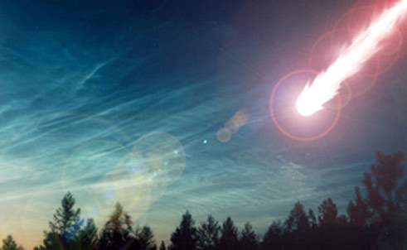
Fig. 23: An exploding asteroid may look like this

Additionally, as the asteroid falls through the atmosphere, a tremendous pressure (M12) builds up on its leading edge and the asteroid ablates by absorbing thermal energy emitted by the hot gases on the leading edge. The mass loss rate can be calculated, as Chyba does, by
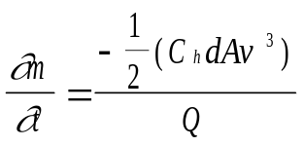
where A is the area of the leading surface, C_{H} is the heat transfer coefficient, and Q is the heat ablation constant for the asteroid’s composition. For a method of successive intervals this becomes
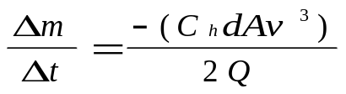
The initial conditions are all well known constants for the composition of the asteroid. The great advantage of the spreadsheet is the ability to change some of these initial conditions. The primary components of the model would be the composition (and therefore the density and mass), and the shape and velocity of the asteroid.
The spreadsheet immediately recalculates all dependent values allowing us to examine many different types of asteroids in a very short period of time.
First, if the asteroid burns up, the mass will be reduced to zero. Secondly, if the interior pressure of the asteroid exceeds the yield strength of the asteroid, it explodes in the air if there is enough time for the shockwave to break up the meteorite. Initially, there is a great pressure build up on the leading edge, the meteorite spreads out quickly like a pancake as the pressure wave moves through the meteorite. The leading edge of the meteorite experiences a pressure of F_{drag}/area, that is, using equation 1,
Pressure = - ½ d v² C_{D} .
The pressure at the rear and sides of the meteorite is not significant compared to this leading edge so that the average interior pressure is
- 1/4 d v² C_{D} (M12).
The asteroid will explode in the air if the shockwave created by the pressure has enough time to travel the length of the asteroid. We can calculate this time from t = L/c (E13) where L is the length of the meteorite and c is the speed of sound (for these solids we’ve estimated 2000 m/s but you can try different values).

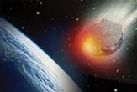
Fig. 24: Asteroid streaking through the atmosphere at about 15 km/s.

One problem is that we do not know enough about the speed of these shock waves in meteorites because their density and composition is largely unknown. Moreover, fragmentation speeds up the breakup of the meteorite.
The great benefit of the spreadsheet is the ability to change a value like this and instantly view the results. So, if we wish to investigate how any changes to this model might affect the breakup of the meteorite we can enter values to test our model. Nevertheless, in this case, the breakup of the meteorite occurs very rapidly, and hence, we have an explosion. Cases where the meteorite does not break so rapidly might explain crater strewn fields on earth.
The last possible scenario for our earthly intruder finds the meteorite making it through the atmosphere without burning up or exploding. In this case, it will impact the ground with a kinetic energy of ½mv². Such an impact is a potential extinction event.

Impact Scenarios
To use the spreadsheet we enter the constants for a given meteorite in row E. Our first example follows Chyba’s model of a stone asteroid of length 100 m (E2) entering the Earth’s atmosphere with an approach angle of 45º (E1) at 15 km/s (E4). The density of stone is 3.5 x 10³ kg/m³ (E3) with a heat ablation (E6) of 8.0 x 10⁶ J/kg and the yield strength of the stone is 1.0 x 10⁷ N/m² (E12). The drag coefficient is 1.5 (E10) and the heat transfer coefficient is 0.1 (E11). For a 100 meter asteroid, the break time is 100/2000 or about 0.05 seconds (E13). Remember that to change the model any of these initial conditions can be modified at any time and the spreadsheet will automatically recalculate the event conditions.
Rows N to S show the calculation for a few intervals. From equation 1, the average drag force acting on the asteroid for the first interval is -1.27 x 10⁶ N (O5). For a 100 m stone asteroid, the interior pressure exceeds the yield strength (1.0 x 10⁷) at an approximate altitude of 9 km (R12, S12). At this time the asteroid still has a velocity of 1.5 x 10⁴ m/s (R4) and it will travel about 3/4 km in the time it takes the asteroid to break up. In other words, the asteroid will explode at approximately 8 km above the Earth. This is exactly the height that the Tunguska asteroid was estimated to have exploded.

Let’s try some other “what if” scenarios.
What happens to a 1 m stone asteroid entering the atmosphere with an approach angle of 45º at a velocity of 15 km/s?”
If we enter 1 in cell E2 the spreadsheet recalculates and we notice that the asteroid burns up completely (mass = 0) before the critical pressure is achieved (columns T - X).
Now try a 1.5 km asteroid entering the atmosphere with an approach angle of 45º at a velocity of 15 km/s.
If we enter 1500 in cell E2 the spreadsheet recalculates and we notice that the pressure exceeds the yield strength at approximately 10 km, similar to the 100 metre asteroid. However, the time for the shockwave to spread across the asteroid is = 1500/2000 = 0.75 seconds. By this time, the asteroid has impacted on the ground with a tremendous kinetic energy.
We can also change the composition of the asteroid by changing the density in cell E3 and the yield strength of the material in cell E12. For example a carbonaceous asteroid would have a density of approximately 2.2 x 10³ Kg/m³ and yield strength of 1.0 x 10⁶ N/m². An iron asteroid would have a density of about 7.9 x 10³ kg/m³ and yield strength of 1.0 x 10⁸ N/m². We find that carbonaceous asteroids explode at higher altitudes above 20 km and that the iron asteroids tend to make it through the atmosphere.

Changing the Spreadsheet
A modelling process such as the earth-asteroid collision is an excellent way for students to be exposed to authentic problems and real-life science. Like most simple models, anomalies can be found.
For example, we can generate an anomaly by considering a 2 m asteroid moving at 15 km/s.
Students are now challenged to explain the error condition in the spreadsheet. Initially, it is not difficult to determine that the spreadsheet is trying to calculate the square root of a negative number in formula M4. This leads us to a discussion of terminal velocity and how we can account for it in the spreadsheet.
Further discussion can lead us to consider the drag force in relation to the changing area of the asteroid, the relative size of the intervals, and the mass rate change for low velocities.
For example, Melosh (1989) adjusts the mass rate change (formula M6) for low velocities using a cut off function (v² - v_{cr}²)/v² where v_{cr} is the critical velocity below which the mass rate change decreases to zero.
We have included a second spreadsheet on the website which deals with these modifications and, using these modifications, we now find that our 2 m stone asteroid travelling at 15 km/s just makes it through the atmosphere, which more closely reflects reality.
Students can also add further modifications to the spreadsheet by changing the formulae in the cells. For example, if you wanted to use a cylinder, instead of a cube for your model of a asteroid you would have to change the formulae for the end surface area to R² , modify the volume used in the mass calculation (E8), and adjust the drag coefficient. Any formula that includes these factors (like drag force) will automatically use these new values in any calculation, so no further change is necessary.
Finally, other more complex factors also affect the descent of the asteroid. In our calculation of the mass loss rate we used a coefficient of heat transfer of 0.1. Chyba reports that C_{h} = 0.1 above ~30 km and varies inversely as the meteorite descends to lower altitudes. Consequently below ~30 km the rate of mass loss stays constant until the cut-off velocity is reached. We have also assumed that the angle of trajectory stays constant during the descent. Students might want to consider how the angle actually changes for small and large asteroids at various speeds. We’ve left these modifications for the more interested and capable student.

Conclusion
The physics of small meteorites is well known, and for large bodies of 1 km and up, the atmosphere does not present a great barrier. They come through without a significant loss in speed, suffering very little deceleration on the way down or sometimes even accelerating to greater speeds. These large bodies do not explode even when encountering the high density at about 10 km. The main reason for this is that the shock waves produced when the body meets the denser part of the atmosphere do not have enough time to cross the body before it reaches the ground.
We have summarized the behaviour of different sizes of asteroids in table 2. The very small particles (the size of dust, 10⁻⁶ to 10⁻⁴ m) decelerate slowly and reach the ground intact; the larger particles, from about 1 mm grains to 1 metre boulders, burn up and little or no solid material is left; and those above 100 m and larger reach the ground virtually at the same speed as their entry speed into the atmosphere. Poorly understood are the behaviour of bodies between about 10m and 100m diameter. These bodies require more research in order to understand what happens to them when they enter the atmosphere at hypersonic speeds. Did an asteroid impact cause the extinction of the dinosaurs 65 million years ago? And what caused the devastation at Tunguska? Are there other answers or can we pronounce the asteroid guilty as charged? Scientists solve these types of mysteries by first proposing a model and then facing the predictions of their model as their model develops into a more sophisticated one and accounts for a wider range of observations. We suggest that students will find this type of modelling activity motivating and interesting.

Table I. Spreadsheet Examples
Since 1972 space sensors have been used in satellites. These sensors are still a military secret, but this much can be revealed: satellites have scanning sensors which operate in the short wavelength region of the electromagnetic spectrum, in infrared. There are sufficient sensors so that essentially the entire world is observed by them 24 hours a day, 7 days a week. The sensors are connected in real time to very large and very fast computers. This expensive system of surveillance was put in by the US government having as its main objective the detection of nuclear explosions, trying to make sure that countries did not violate the UN decision against nuclear testing. What they found was disturbing. Over just a short period the sensors detected explosions (using their very sensitive infrared sensors) that suggested nuclear testing occurred in many places over the entire globe. Soon, however, it was pointed out to the military by astronomers that what they were seeing were impacts made on Earth by meteorites. So we now have another excellent “spin-off” from military technology that is indispensable for detecting and studying the type and the frequency of impacts from asteroid and Meteorites.

Testing our model
1. Use our model for “what if a bolide impacted...”, assuming that:
a. The bolide was about 10 m across and was a carbonaceous chondrite
b. The entry speed was about 15 km/s
c. The angle of entry was about 15 degrees to the horizontal

2. Test our model against the conclusions that scientists made, as enumerated above. Comment.

The Barringer crater: A science mystery solved
The most visible crater in North America and probably the finest surviving impact crater on Earth is the Barringer crater in Arizona. It is a giant hole in the middle of the arid sandstone desert. There is a rim of smashed and jumbled boulders, some the size of small houses rising 50 meters above the level of the surrounding plain. When Europeans first discovered the crater some 400 years ago the plainaround the large hole was covered with chunks of meteoritic iron, about 30 tons of it, scattered across an area over 10 km in diameter.
We now know that the crater was produced by the impact of a small nickel-iron asteroid or meteorite about 50,000 years ago. This 1.2 km wide bowl-shaped excavation is a classic example of what geologists call a simple crater. The crater has been studied extensively and the rocks in it analyzed. For example, the rocks on the floor show evidence of high velocity impact. It is interesting that the meteorite that formed this crater was only about 50 meters in diameter and had a mass of less than 1 megaton. It hit the Earth with a speed of about 15 km/s and released the energy equivalent to about 10 - 20 megatons of TNT. The Hiroshima bomb had a Meteorite impacts had been reported for thousands of years but until the beginning of the 20th century no one had ever identified a crater created by such a fall. The largest meteorite ever found is Hoba West, in South West Africa. It has a volume of about 10 cubic meters and a mass of 66 metric tons. It was slowed down by the atmosphere so much that upon landing it did not make a significant hole. It took about 50 years of arguments, sorting out what counted as evidence, to arrive at our understanding of the mechanism of meteorite impact.
We will reconstruct the story of the Barringer crater to illustrate that scientific discovery is a human undertaking, is complex, unpredictable and cannot be pinned down by a “scientific method” that is “fool-proof”. The process of scientific discovery involves the development of hypotheses, the sorting out of what does and what does not count as evidence to support that hypothesis, the interpretation of observable “facts”, tentative explanations in the face of incomplete data, the ability to persuade your peers, and just good luck. A good hypothesis generates a number of consequences or predictions, which are capable of being tested. The hypothesis that is ultimately accepted as scientifically valid, only if:
1. repeated tests of the predictions made and by different investigators, tend to confirm it;
2. it is consistent with all other well-confirmed hypotheses;
3. it is better than other hypotheses in accounting for a broad range of observed “facts”
4. it is more economical, more “elegant” and “simpler” than competing hypotheses.

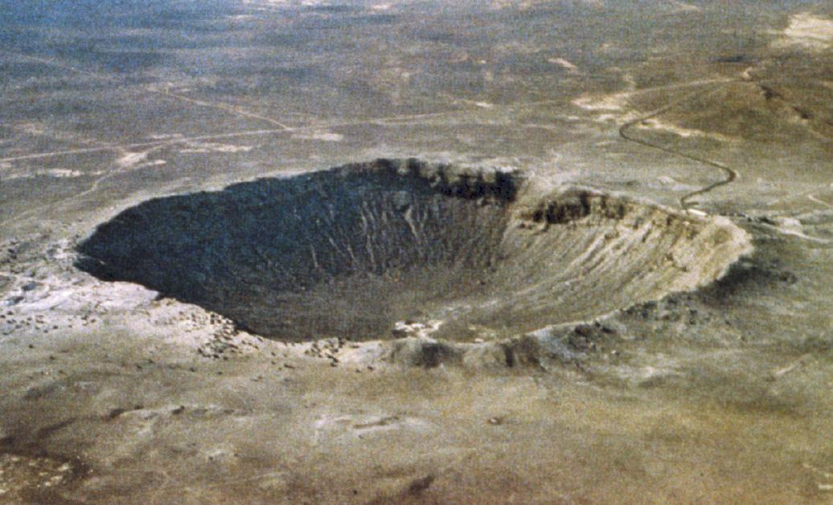
Fig. 25: The Barringer crater in the Arizona desert.

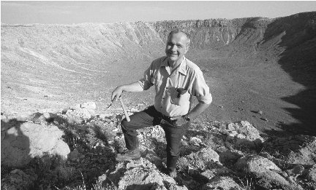
Fig. 26: Astrogeologist Eugene Shoemaker poses on the rim of Arizona's Barringer Crater, which formed from the impact of a metallic asteroid, about 50,000 years ago.

Phase I: What produced the big hole in the desert?
In 1891 Karl Gilbert, then chief geologist for the U.S. Geological Survey, decided to test two opposing hypotheses about the origin of a large hole in Arizona . The first claimed that the big hole in the desert was the result of an impact by a giant meteorite and second hypothesis that it was produced by an explosion of superheated steam, caused by volcanic activity far below the surface. Gilbert assumed that if the iron meteorite had created the crater then it must have been as big as the crater itself. He then tested the predictions made by these two competing hypotheses.
First, he argued that the meteorite should be taking up a lot of space in the hollow of the crater. The volume of the hollow would therefore be less than the volume of the ejected material in the crater rim. Second, he was sure that the presence of a large mass of buried iron should effect a compass needle.
Neither prediction was confirmed. Therefore Gilbert concluded that the steam explosion hypothesis was the only one that could be scientifically acceptable. It is interesting to note that he came to this conclusion in spite of the fact that no volcanic rocks had ever been found in this area. Were the meteorites around the crater simply a coincidence?

Phase II: Why not attempt to mine the crater?
Ten years later, Daniel Barringer, a successful mining engineer, heard about the crater. When he learned that small balls of meteoritic iron were found randomly mixed with the ejected rock of the crater rim, he immediately concluded that the crater was the result of an impact with a meteorite. He reasoned that if the meteorites had fallen at a different time from that of the formation of the crater, pressures and temperatures of the impact. However, Barringer was so confident about his scientific reasoning that he formed the Standard Iron Company and began securing mining patents.
This mining venture, which was later seen to be based on faulty scientific reasoning, cost him and his associates $600,000 (about $10 ,000,000 in today’s currency) and lasted for 27 years without producing any profit. However, as a result of his persistence, we have a splendid science story. Barringer actually succeeded in convincing much of the scientific community of his impact theory. In 1906 and again in 1907 he presented his arguments for the impact hypothesis to the Academy of Natural Sciences in Philadelphia.
The argument for his hypothesis was based on:
a. The presence of millions tons of finely pulverized silica could only have been created by enormous pressure.
b. The large quantities of meteoritic iron, in the form of globular “shale balls”, scattered around the rim.
c. The random mixture of meteoric material and ejected rocks.
d. The different types of rocks in the rim and the surrounding plain which appeared to be have been deposited in the opposite order from their order in the underlying rock beds.
e. There was no naturally occurring volcanic rock in the vicinity of the crater.

Phase III: Where was the meteorite?
The last attempt to find the buried meteorite was made in 1928 after Barringer raised $200,000 (about $3,000,000 in today’s currency). The new mine shaft hit water and there was no trace of a buried meteorite. In a final attempt to clear up the mystery, the astronomer F.R. Moulton was consulted for his opinion on the size of the meteorite that produced the crater.
Moulton calculated the energy which would be produced by a very high-velocity impact that was known to be typical of a meteorite colliding with the Earth’s atmosphere. He concluded that an object capable of producing a crater of the size of the one in Arizona would only have a mass of about 300, 000 metric tons, only about 3% of the mass hoped for by Barringer. This amount was far too small to justify any further drilling. Moulton also argued that the explosion caused by the impact would totally vaporize the meteorite!

Phase IV: What have we learned since then?
In 1946 Harvey Nininger analyzed the tiny metallic particles that were found mixed in the soil around the crater, along with the small “bombs” of melted rock inside it. He concluded that both types of particles were solidified droplets, which must have condensed from a cloud of rock and metal that were vaporized by the impact. He thought that this was confirmation of an explosion occurring.
In 1960 the famous geologist Eugene Shoemaker (of comet Shoemaker-Levy fame) and his co-workers discovered a new mineral called “coesite” at the Barringer crater. This mineral was first created in a laboratory in 1953. Its formation requires a pressure of at least 20,000 atmospheres and temperatures of at least 700 degrees Celsius. We do not find pressures or temperatures this high naturally on Earth.
In 1963 Shoemaker published a landmark paper in which he analyzed the similarities between the Barringer crater and the craters created by nuclear test explosions in the Nevada desert. After careful mapping of the sequence of layers of the underlying rock, and the layers of the ejecta, he found that the layers were deposited in reverse order. He thus demonstrated that nuclear craters and the Barringer crater structurally similar in almost all respects.
Finally, we now know that impact cratering is the only geological process known to produce shock-metaphoric effects. The evidence, unfortunately, is often buried in simple craters. The pressure and temperature required for these effects are of the order of 10 gigapascals and over 1000 degrees Celsius. In complex craters, on the other hand, the raised center exposes the shocked rocks, such as easily identifiable shatter cones, and therefore can be easily identified as an impact crater. The Barringer crater is a good example of a simple crater.
Our science story about the crater in Arizona spans the time of more than 50 years, and is the story of a confrontation between two opposing hypotheses that was finally clearly resolved. We will see that the next science story, the almost 100 year attempt to explain the mystery behind the most famous extra-terrestrial collision in history, is even more complex and is, in the minds of some scientists, still not settled.

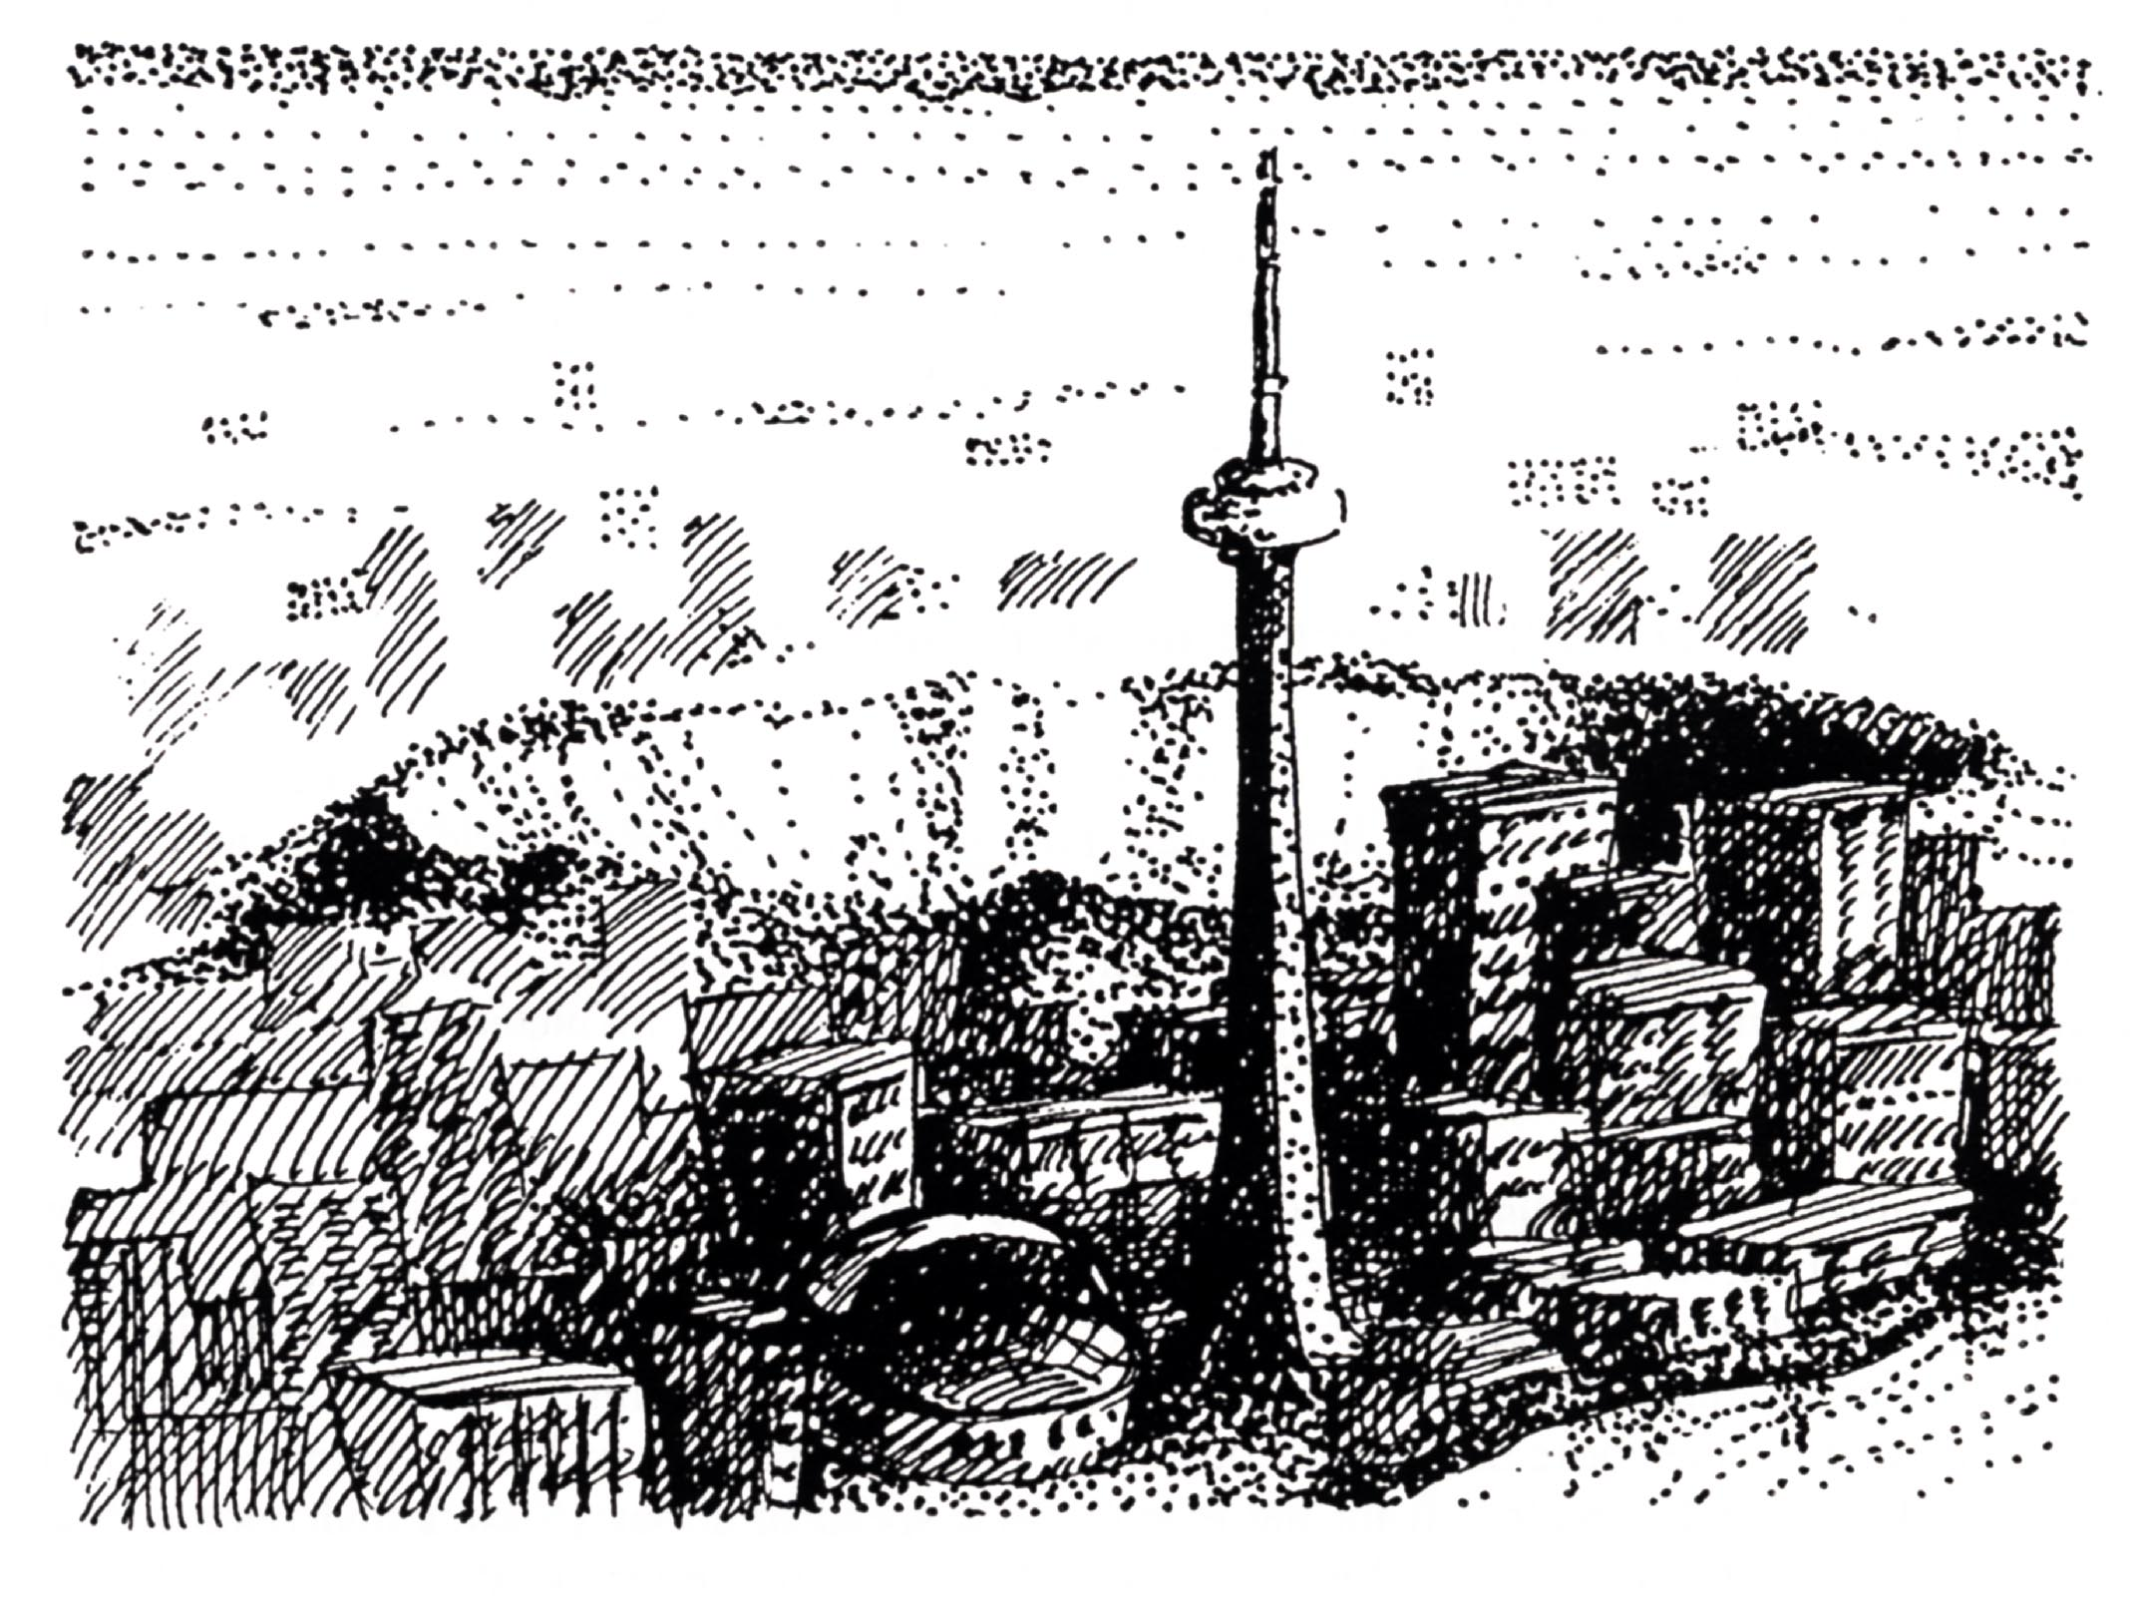
Fig. 27: The Barringer Crater “displaced” to Toronto.

Questions
1. Scientific progress is often connected to complex interactions between personal needs, technological limitations, good hypothesis generation and sound reasoning. Show how the story of the mystery of the origin of the Barringer crater illustrates this complex interactio
2. As late as the 1950s, many astronomer and geologists still believed that the craters on the Moon were produced by volcanic activity. Only by the 1970s did science textbook “catch up” with the ideas of scientists such as Gene Shoemaker.
a. What were Shoemaker’s arguments for believing that the craters on the moon were caused by impact of objects, rather than volcanic activity?
b. Why do you think new ideas in science (what some science historians call “paradigm-shift) take so long to appear in standard textbooks? Discuss.

Problems
1. Barringer estimated the size of the meteorite that fell into the Arizona desert from the size of the crater and found it to be approximately 10,000,000, or 10 Megatons . The average density of the meteorite has to be guessed to be between about 2 and 5 g/cm³. Consider a bowl of 1200 meters across and 170 meters deep (see Fig. ). The bottom of the “lens” is 380 meters deep. Estimate the volume of the crater and compare your value with that calculated by Barringe
2. The astronomer Moulton hypothesized that the damage done was produced by a meteorite of about 50-60 m across and arriving with a speed of about 15 km/s, relative to the Earth. Estimate:
a. the mass of the meteorite. Moulton calculated it to be about 300,000 tons.
b. the energy of impact. In other words, calculate the kinetic energy of the meteorite upon impact.
c. find the TNT equivalent. This is equivalent to a powerful nuclear explosion, or to about 10 Megatons of TNT exploding.
Note: 1 Ton of TNT is equivalent to 4.15 x 10⁹ Joules. A Hiroshima-type nuclear (fission) bomb is equivalent to 1.5 x 10⁴, or 15 kilotons of TNT. A Hydrogen (fusion) bomb is typically of the order of 10 Megatons of TNT.
3. It is claimed that in estimating the damage caused by an impact the “hundred times as much energy” rule applies. This means that “every gram of impacting material carries an energy approximately equal to 100 g rams of TNT”. Check this statement and decide what assumptions are made.

Impact craters in Canada: student research
There are many impact craters in Canada, ranging in size from about 0.5 km to over 100 km in diameter. Some of them are visible and clearly identifiable, but a few have been discovered only recently. The following are some of the craters that you can read about using the Internet:
Sudbury crater, Ontario
Deep Bay, Saskatchewan
Manicougan, Quebec
Mistastin Lake , Nova Scotia
West Hawk Lake, Manitoba
Saint Martin, Manitoba
Montagnais, Nova Scotia
Clearwater Lake West, Ontario
Clearwater Lake East, Ontario
1. Find the location (latitude and longitude), the age of the crater, whether or not the crater is exposed at the surface and the date of discovery.
2. Guess the size and mass of the impacting asteroid for each case.
3. Estimate the energy involved for each case.
4. After reading and studying the section on the model we developed, describe the “passage through the atmosphere” for each impacting object.

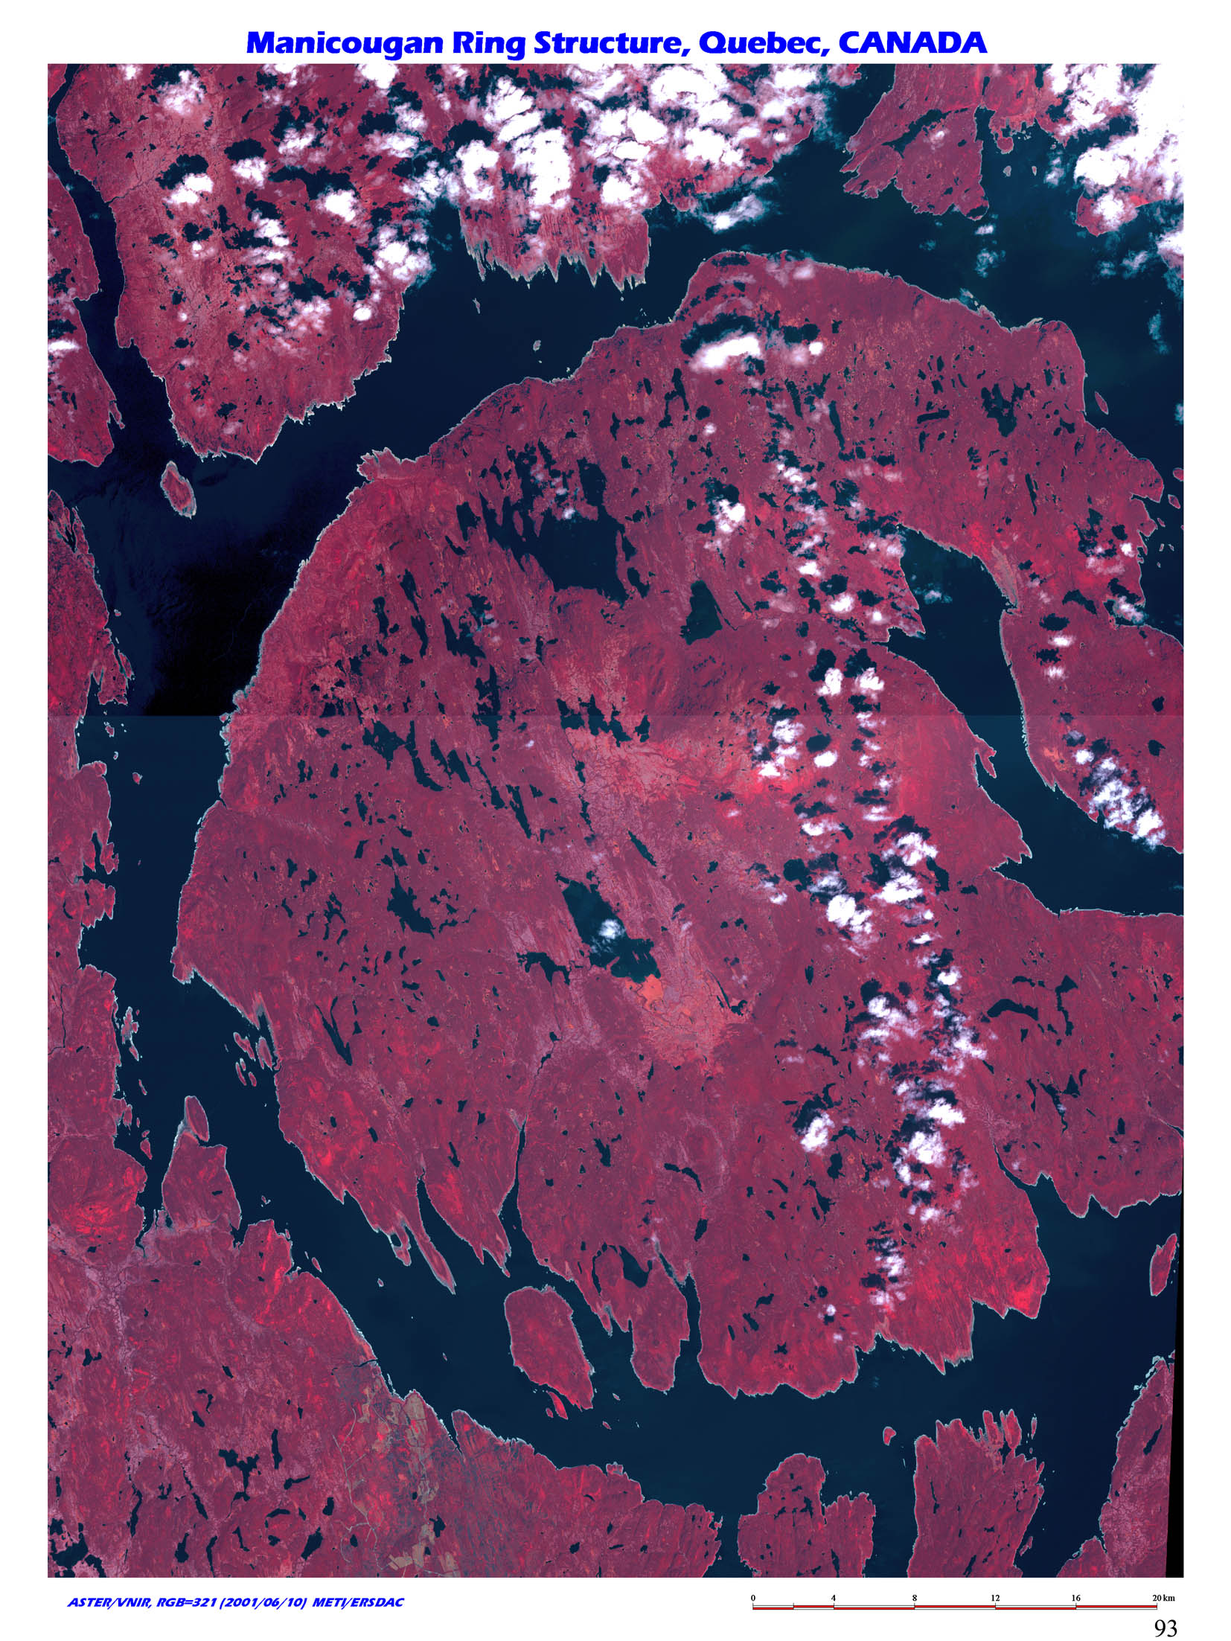
Fig. 28: The world's largest class of impact crater, Manicougan Imapct Crater, Quebec, Canada / (N51 25/W68 40) Impact Crater in southern Labrador

The Manicouagan crater lies in northern Quebec, Canada (Lat 51° 23' N, Long 68° 42' W). It is one of the largest and oldest known, with a diameter of about 100 km. The crater is a multiple-ring structure, but the feature that shows up best in this NASA Landsat satellite photo is the inner ring, which is occupied by a lake (Manicouagan Reservoir) with an outer diameter of about 70 km.
The impact occurred 214 million years ago. The asteroid probably had a diameter of about 5 km. It may have produced a mass extinction similar to that at the end of the Cretaceous period.

IL19 *** Impact craters in Canada
http://en.wikipedia.org/wiki/List_of_impact_craters_in_Canada

Impact Craters: Global distribution
There are about 150 craters (impact structures) on Earth, most of which are less than about 200 million years (My) old. These craters represent only a small portion of what would have been a much larger number. Most craters must have been buried or destroyed by the dynamics of tectonic motion as well as the erosional activities of the planet.
Look up on the Internet a list of all known (about 150) craters on Earth. These are described in terms of Location (longitude and latitude), Diameter (kilometers), and Age (Millions of years).
1. Using an atlas, get an understanding of their global distribution.
2. Place them in 100 MY intervals with the corresponding number of craters.
3. Plot a graph of crater size and number of craters. Use sizes of 1-10 km, 10-50 km, 50-100 km, and larger than 100 km.
4. Find the craters that have an age of approximately 210 My, that is, those that are between 200 and 220 My.

Questions
1. How many craters are there over 100 km in diameter? A crater of this size impacted on the Yucatan peninsula about 65 million years ago, causing a devastation on Earth, as we shall see later.
2. Gene Shoemaker believed that only about 10% of the impacts on Earth have left a lasting mark. Discuss.
3. If the surface of the Earth were solid, approximately how many craters would be visible?
4. In your list taken from the Internet you should have found five craters that have an age of about 210 My. Name these craters and describe them. File them away for an important discussion in the section “Jovian Fireworks”.

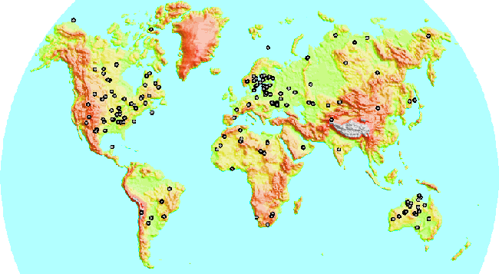
Fig. 29: Known impact sites on the Earth's continents. See also LPI's Terrestrial Impact Site for pictures of the crater

More recent recorded collisions:
The Revelstoke Bolide: The first “Earth grazer” detected
Meteoroid impacts are generally of little interest, but impacts that release large amount of energy, like fireballs, are. It is not well known that in March of 1965 a small bolide, travelling at a very shallow angle (about 15 degrees to the horizontal), first seen as a fireball, exploded at a height of about 30 km above Revelstoke, British Columbia, with an estimated energy of about 30 kilotons of TNT equivalent. This is about 5% of the energy of the Tunguska explosion, but equivalent to several Hiroshima nuclear bombs.
What saved Revelstoke, of course, was the fact that the body exploded at 30 km height and not at about 8 km like the Tunguska bolide did. Examination of recovered material showed that it was a carbonaceous chondrite. Largely unprocessed 1mm sized fragments were recovered from the Revelstoke site, but almost nothing was found at the Tunguska site. We must remember, however, that the first scientific exhibition reaching the Tunguska site was 20 years later. It is therefore not surprising that only small amounts of spherules of vaporized and recondensed material were found. We will see later that when we apply a simple model to understand why and how bolides explode at various heights, the Revelstoke explosion at about 30 km is consistent with a 10 m carbonaceous chondrite that entered the atmosphere with a speed of about 15 km/s.

IL20 *** Official entry of the Revelstoke bolide of 1965
http://tin.er.usgs.gov/meteor/metbull.php?code=22592

The official report of the incident:
An extremely bright bolide giving off sparks was observed to travel for 100 km. (8 seconds) at 15° inclination; blue white at high altitudes, it exploded at 30 km. with a brilliant flash of white light, and travelled onward as two or more distinct reddish fireballs which went out at an altitude of 12 km. over a very wild and desolate range of glaciated mountains and spruce forest. Violent detonations were heard up to 130 km. from the fall area and were recorded on four seismographs as much as 400 km. distant. Search by plane and helicopter immediately after the fall was unsuccessful, but two guides and trappers living ten km. south of the fall area in the course of their spring trapping operations for beaver, observed two impact areas on the ice of a small lake, and another two in the snow of the neighbouring forest. These small fragments lay directly along the trace of trajectory plotted by Drs. J. Galt and E. Argyle of the Dominion Radio Astro Physical Laboratory at Penticton, British Columbia, and L. Bayrock of the Research Council of Alberta, Edmonton. Two of the samples of disaggregated meteorite were collected, the other two were lost on melting of the lake and snow. Identification was made at the, University of Alberta and confirmed by the Geological Survey of Canada, Ottawa. Search for the main mass or masses is continuing, using air photographs taken shortly after the fall and helicopters to support ground search.
Source: Report of Prof. R. E. Folinsbee (Edmonton, Canada) in a letter, VII.26 1965.

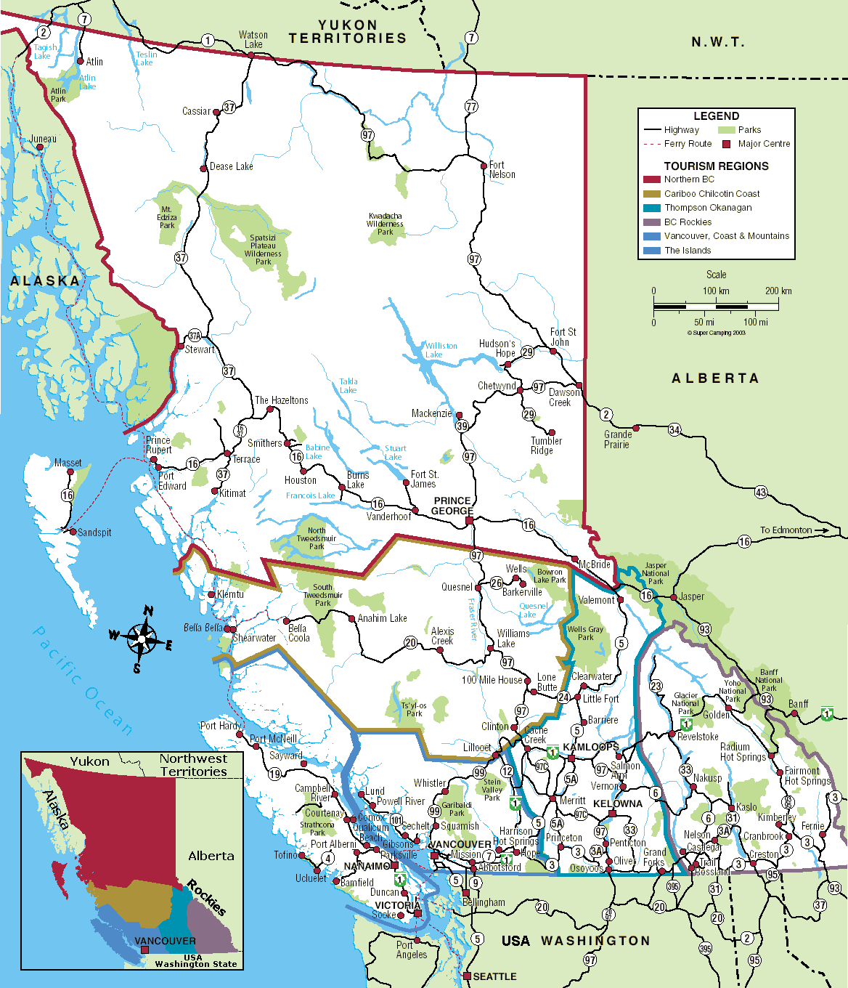
Revelstoke, B.C.
Fig. 30: Revelstoke, BC.

The Utah-Alberta fire-ball
The very first recorded event was an Earth grazer that entered the atmosphere on August 10 1972. The object entered the atmosphere over Utahh, close to Salt Lake City, travelled through the atmosphere for several thousand kilometers on a northerly heading and skidded out of the atmosphere just south of Edmonton, Alberta. Later analysis of this event revealed that the object was an Apollo asteroid, about 10 meters across and travelling at about 20 km/s. It was first detected at an altitude of 73 km, tracked down to 53 km, and then tracked as it climbed back out of the atmosphere. This was a very bright daylight fireball seen by hundreds of people on the ground from Utah to Alberta. The object tracked across Lake Tacho and the Grand Tetons, and after the hundreds of reports were gathered, the media was alerted. There were many still and moving pictures taken of the object as it. This object is still in an Earth-crossing orbit around the sun and passed close to the Earth again in August, 1997. There were altogether 336 events of this magnitude recorded between 1972 and 1997 by these new sensors placed in satellites. When these events are shown on a world map, you can see that no place on Earth is safe.

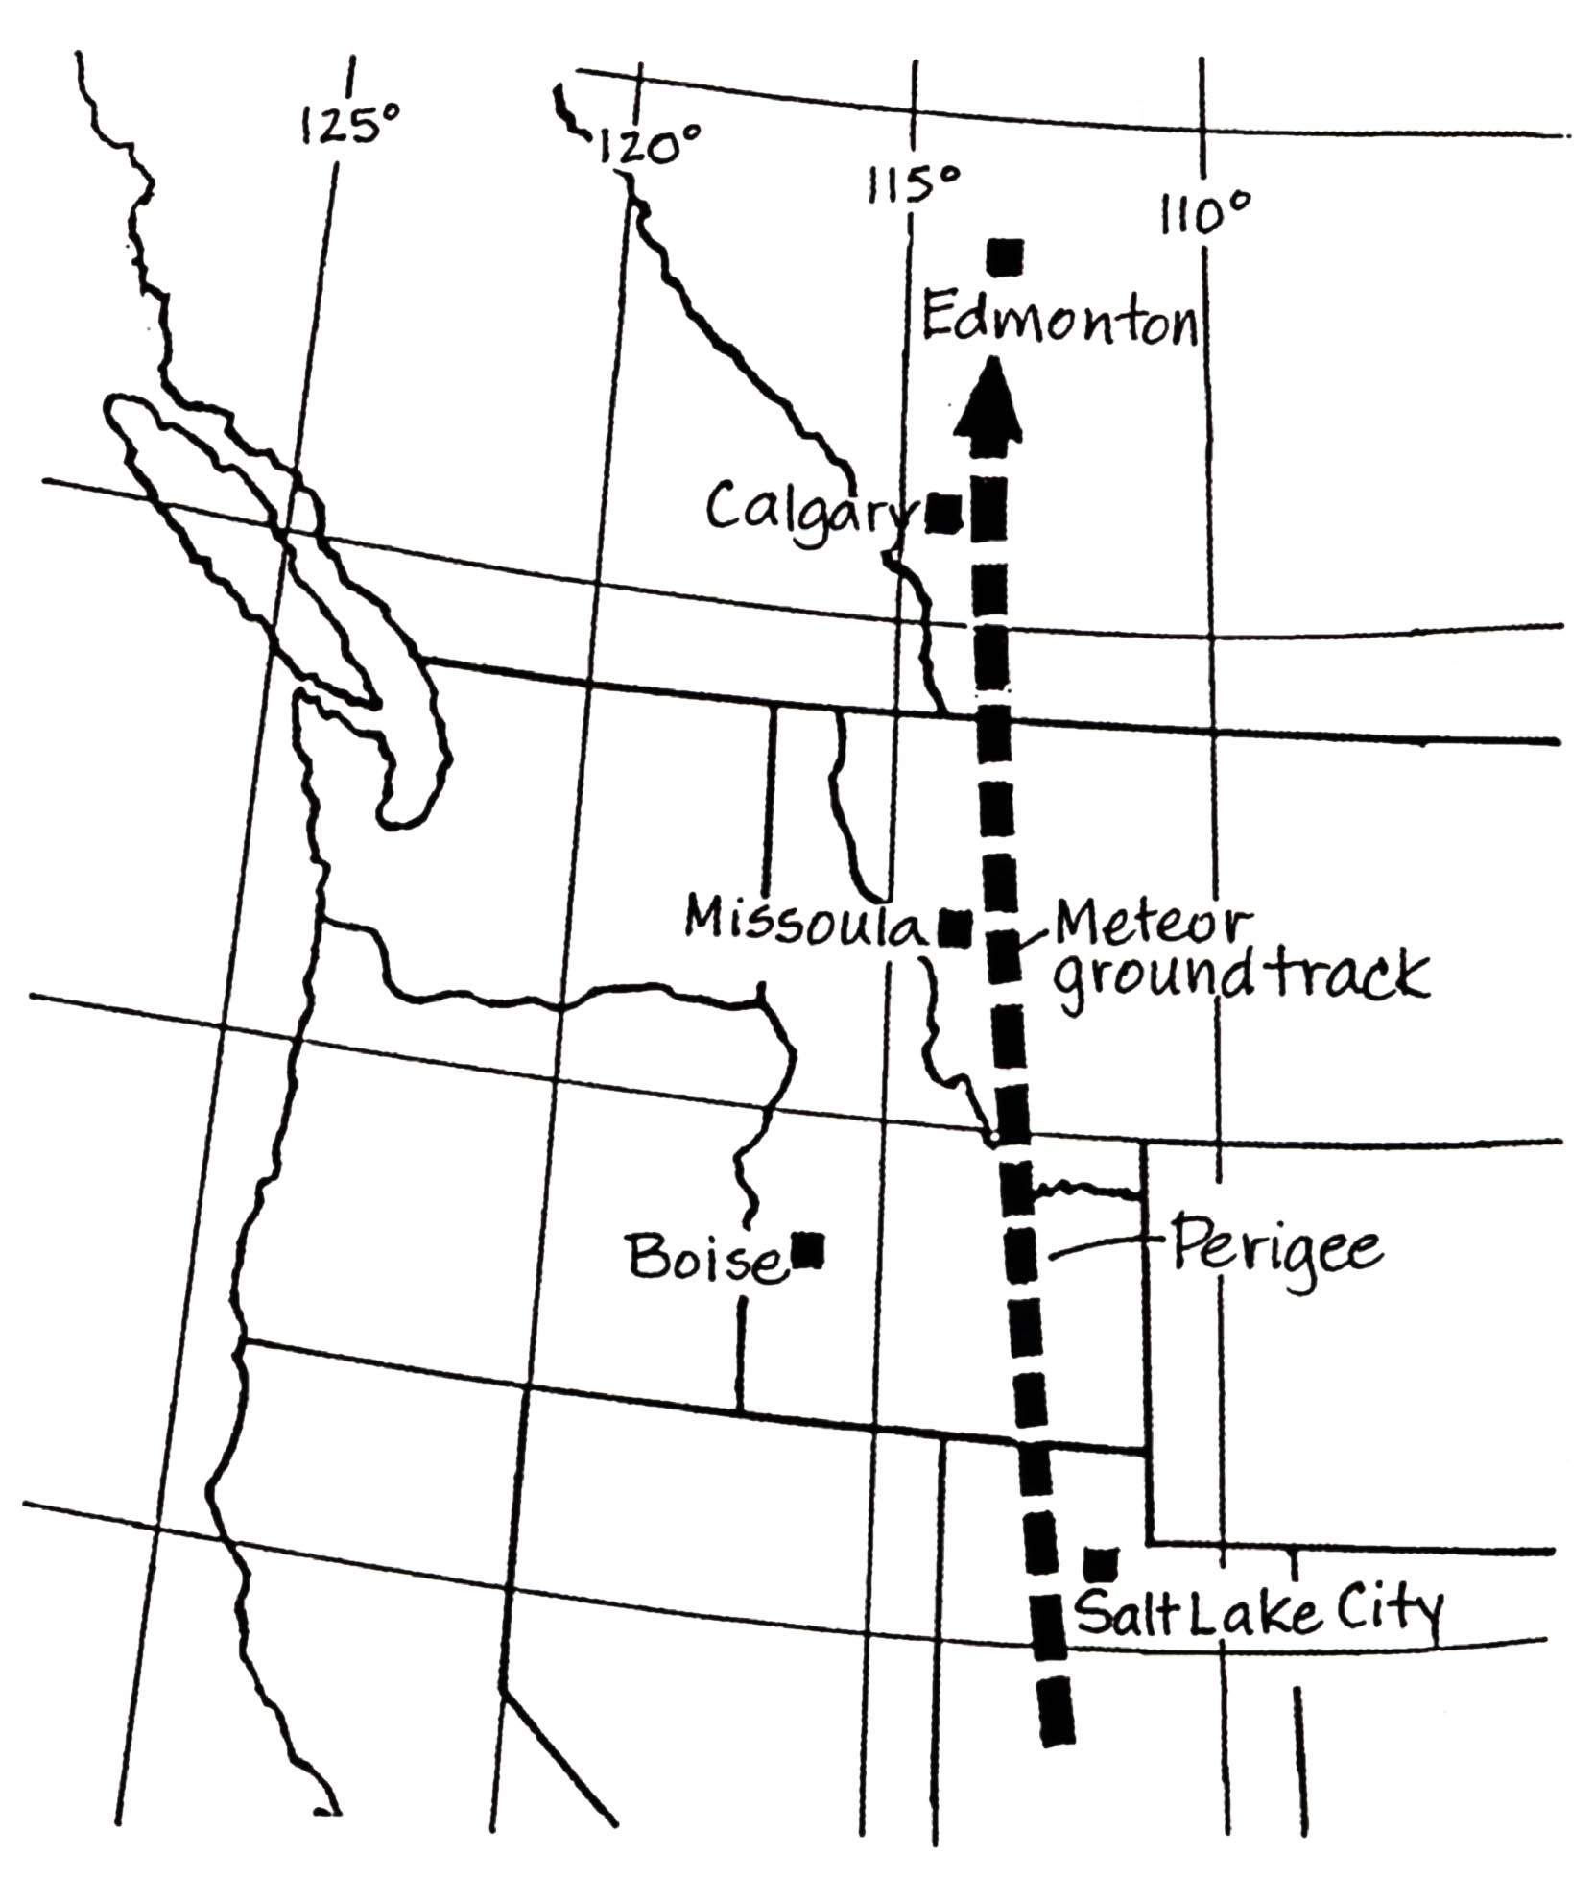
Fig. 31: The Utah-Alberta fireball’s trajectory

Going beyond our model
The following is a “guided” problem to allow you to work through the details and become acquainted with the way scientists work through problems like this as a routine. This exercise could be a first step to extending our model to include bolides that become “fireballs” and skip out of the atmosphere, back into space.
The report (see references) from which the above data are taken stated simply:” Analysis has revealed that the object, which passed into the atmosphere and eventually headed back out into outer space, is an Apollo asteroid about 10 meters in size, etc. These are the data given to us:
To get you started consider the following: You are in Salt Lake City on 10 August, 1972, looking in a westerly direction, you notice a fireball at about a 45 degree angle moving very quickly across the sky in a northerly direction. At the same time, a jetliner is flying overhead, also flying in a northerly direction. You notice that the fireball very slowly “catches up” with the jetliner, is overlapped by it for a few seconds and then slowly moves ahead of the liner. You estimate the height of the jetliner to be about 10,000 m and its speed about 750 km/h (These are reasonable estimates). What would you be able to conclude about the height of the fireball and about its velocity with these data, if anything?
Suppose that the next day you here a report (remember this took place before the Internet and PCs) on the radio that astronomers have estimated the height of entry to be 73 km. Could you now make a reasonable guess about the speed of the meteoroid? Discuss. How was the height of entry established? Discuss. The challenging problem now is to estimate the exit velocity of the meteoroid:
a. We know that the velocity must be higher than about 11 km/s. Why?
b. The next question is: “how much energy was lost by the interaction with the atmosphere?
This would be a simple problem to solve if we knew the exit velocity. Why? How can we find this velocity?
First, we make an approximation by assuming the meteoroid was moving at the same height (average between 73 and 53 km) where the density of air can be considered constant. The density of the air at a height of about 63 km is approximately 2x10⁻⁴ kg/m³., or about 1/10000 of the density on the surface of the Earth.
Referring to the previous section were we discussed the air drag on a 60 m asteroid we used the important relationship: F_{D} = -½ d V² A C_{D}
We can use the same relationship for the 10 meter rock hurling through the atmosphere. As before, we will consider the drag coefficient to be 1.0 since this is essentially large cube hurling through the air.
a. Find the resistance force of the atmosphere on the meteoroid.
b. Find the deceleration using simple kinematic equations.
c. Show that the meteoroid slowed down very little during the transit as it skipped out into space, having been redirected by the encounter, perhaps to come back for an another close encounter at a future date.
d. It is interesting the find out how much energy the meteoroid gained when in dropped from 73 km a height of 53 km. Show that this energy is only about 1 percent of the energy lost due to the transit.
Again, we were lucky. Had the 10 meter stony asteroid come through the atmosphere as was the case in Tunguska, say over Salt Lake City or Edmonton we would have had a major disaster. The Tunguska event was certainley large, that bolide may have been ten times the cross section of this one. Still a direct hit on one of these cities would have been catastrophic.
e. There is good reason to believe that this was a rocky asteroid that may have exploded at about 10 km above the surface of the Earth. We are now ready develop a simple model and calculate the forces involved if such a large meteorite or (small asteroid) collided with the Earth directly.

The Estonia Fireball
On June 1.1937 a brilliant fireball was seen over Estonia and a crater of 8.5 meters in diameter was formed by the impacting meteorite. Unfortunately, the event was not studied until fifty years later. Astronomers made calculations, based on its brightness, and put its mass at above 50 tons . However, the meteorite reaching the ground could not have been much larger than about 500 kg, the rest burning up in the atmosphere in transit. An explosion occurred at a height of 28 km. You will recall that the Tunguska object had a mass a 1000 times larger and produced no crater at all. Moreover, there was no evidence of any meteorite remnant in the area, when the first scientific study was done in 1928, 20 years later.
Problems:
1. Using the rough relationship that the diameter of the crater produced by an iron meteorite is about 10 times the diameter of the meteorite, estimate the size and the mass of the impacting object.
2. Based on our model, what kind of asteroid was it?
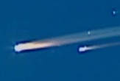
Fig. 32: The Estonia fireball

Testing our model
Now use our model and find out:
a. what would have happened if the 10m stone bolide had barrelled through the atmosphere at a steep angle, with a speed of about 15 km/s over Edmonton. Describe what would have happened.
b. if our model predicts for the Estonia fireball that over 90 percent of the mass would burn up and that an explosion would occur at a height of 28 km.

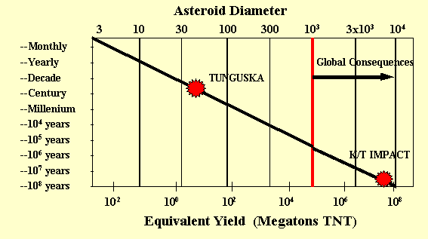
Fig. 33: The relationship between the frequency of events and the TNT equivalent yield.

Dinosaur Extinction: A Confrontation Between Two Theories

Kilometer-sized asteroids and comets cause global scale disasters when they hit Earth. Ames' researchers found that the Chicxulub crater in the Yucatan Peninsula is the site of an impact 65 million years ago that killed the dinosaurs.

Known as the K-T impact, it led to massive extinctions throughout the biosphere, while it paved the way for the ascent of mammals and the rise of humans. Recently, Ames' astronomers have pointed out that future collisions are inevitable. If we wish to avoid the fate of the dinosaurs we need to be alert for colliding objects. NASA report.

About 65 million years ago a great change took place: more than half of the world’s reptiles vanished along with more than half of all species of plants, land and marine animals, including the dinosaurs. Mammals somehow survived and became the dominant large animal. One of these species lived long enough to eventually to investigate the fossil record of its distant origins and ask the question:
Who or what committed the mass murder?
It is almost certain that a large asteroid created the 180km Chicxulub crater off the coast of the Yucatan 65 million years ago. The impact that produced this crater has been strongly linked to the mass extinction event that eliminated the dinosaurs.

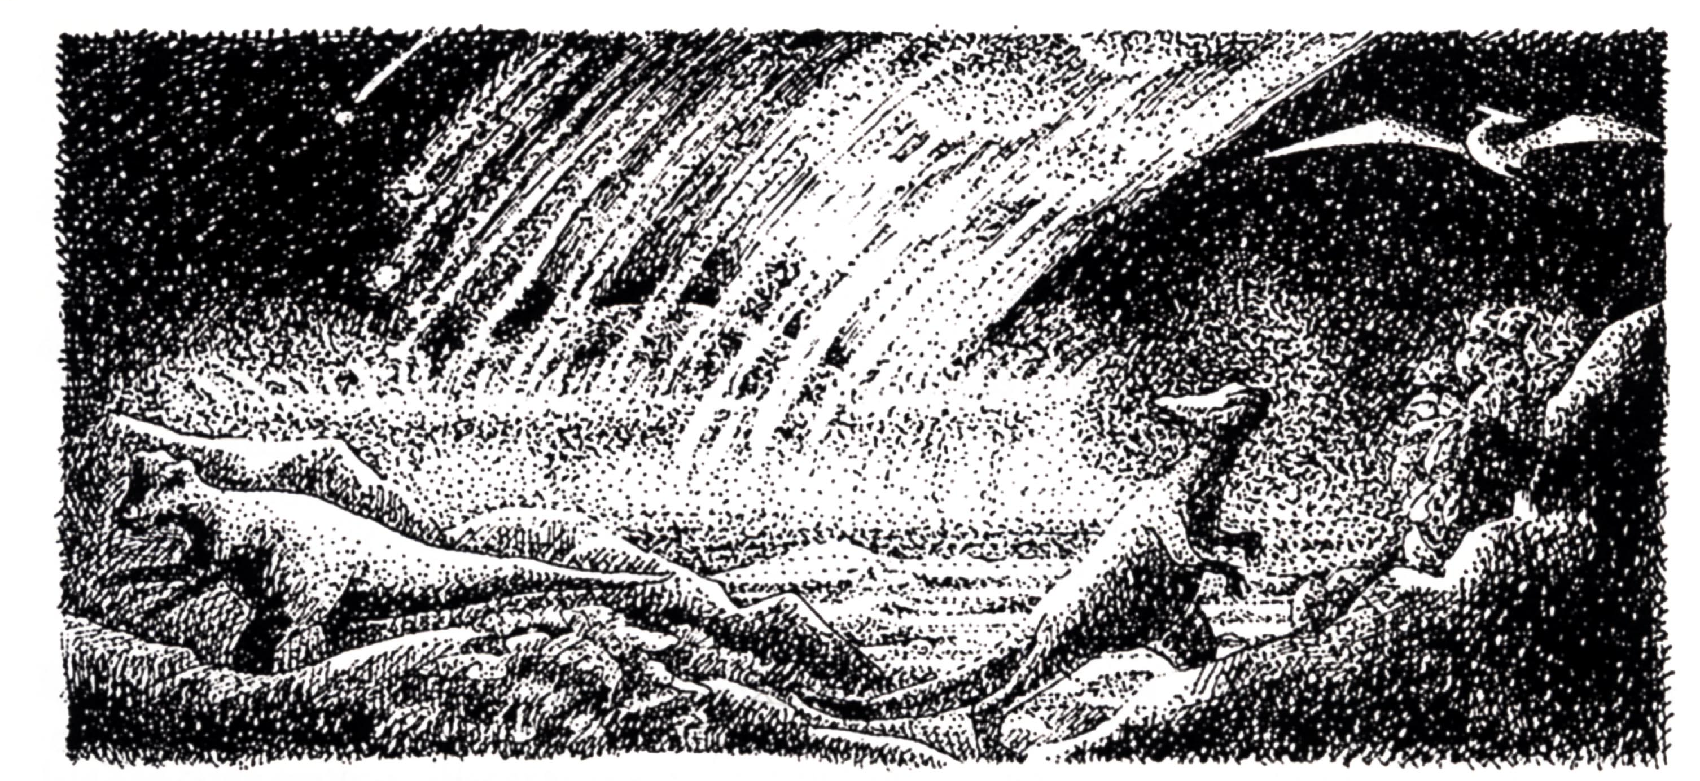
Fig. 34: An artist’s imagination: The Yucatan Asteroid Impact

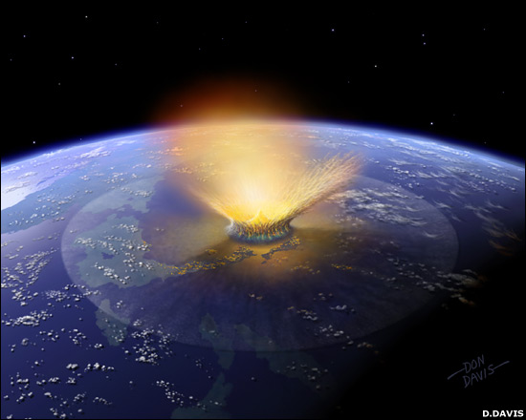
Fig. 35: An artist’s rendition of the Chicxulub collision

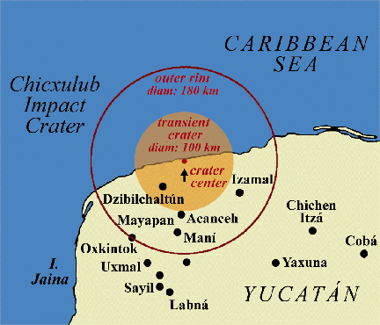

Fig. 36: The center of the Yucatán crater at latitude 21º30' N, longitude 89º50' W lies at the village of Chicxulub, near Progreso on the Caribbean coast.

The puzzle presented by mass extinction is both like and unlike that of a more recent murder. There is evidence - chemical anomalies, mineral grains and isotopic ratios instead of blood and fingerprints or torn matchbooks - scattered throughout the world. No witnesses remain, however, and no chance exists of obtaining a confession. The passage of millions of years has destroyed or degraded most of the evidence in the case, leaving only the subtlest clues.

IL21 *** The KT extinction
http://www.ucmp.berkeley.edu/education/events/cowen1b.html

Taken from IL21 above:
The impact caused a tremendous shock wave while transferring energy and momentum to the ground. The energy of the Chicxulub impact dwarfs anything modern civilization has experienced. The energy of the impact was comparable to 100 million megatons of TNT, 6 million times more energetic than the 1980 Mount St. Helens volcanic eruption. The impact ejected rock from several kilometers beneath the surface of the Earth and carved out a bowl-shaped crater nearly 100 km in diameter. In addition, the shock of the impact produced magnitude-10 earthquakes, which were greater than the magnitude of any we have ever measured in modern times.
It was known already in the last century that the most abrupt reduction in diversity (extinction) of species occurred at the boundary between the Cretaceous and Tertiary periods, 65 million years ago. Darwinian evolution was based on the nineteenth century geologist Charles Lyell’s idea of uniformitarianism (see The Age -of-the-Earth Debate, Chapter X) which did not allow for discontinuities (sudden changes) brought about by catastrophes. The idea that everything on Earth could be explained by gradual changes as laid out in Lyell’s influential book Principles of Geology (1830) become a truism among geologists. In the 1960s and 1970s, however, paleontologists began carefully to compile records of taxa seen in the strata of different ages. It soon became clear that there were indeed times of very high extinction rates. In particular the Cretaceous - Tertiary boundary, generally designated as the K-T boundary in geology, (the K is derived from Kreide, meaning “chalk” in German), showed extremely high rates. This is the boundary between the older Mesozoic Age of Reptiles and the Modern Mesozoic Age of Mammals.
To complicate the investigation, the extinctions coincided with massive eruptions of the so called Deccan Traps volcanism in India. (Deccan means “southern” in Sanscrit and trap means “staircase” in Dutch). The Deccan Traps flooded the Earth’s surface with the “greenhouse” gas, carbon dioxide (CO₂ ), triggering greenhouse climate change.
Two major “theories” (they could also be called “hypotheses”) were put forward in the late 1970s: the asteroid impact hypothesis ( by Walter Alvarez, American geologist and his father, Luis Alvarez, American Nobel lauriate physicist), and the volcano greenhouse hypothesis (by Dewey McLean, an America geologist).
The Asteroid Impact Hypothesis
This hypothesis holds that a giant asteroid of about 10 km cross-section plunged into the Earth’s atmosphere at more than 10 km/s. The enormous energy involved in such a collision caused a serious chain of disasters, such as storms, tsunamis, cold and darkness, acid rain, and global fires. The evidence and the argument to back up this theory make another great scientific detective story. What makes this story especially interesting is the productive collaboration between a physicist, Nobel lauriate Luis Alvarez, a geologist, Walter Alvarez, his son, a chemist, Frank Asaro, and a paleontologist, Helen Michael.
Originally, Walter Alvarez was looking for a way to quantify the rates of faunal change around the K-T boundary. To do this he needed a time keeper. His father suggested that they use the empirical finding that the platinum group of elements (platinum, iridium, osmium, and rhodium) are much less abundant in the Earth’s crust and upper mantle than they are in meteorites and in solar system material in general. The lack of these elements is probably due to their high density. To their surprise the scientists found concentrations of Iridium 10 times the normal in clay layers, exactly where the K-T extinction occurred. The high concentration later turned out to be a global feature and found in all clay layers in all K-T boundaries. Two initial hypotheses were discussed:
1. Something shut off the production of clay, while the rain of iridium in space remained constant.
2. Something boosted the amount of space dust (and hence the deposition of iridium) by an order of magnitude (10 times more).
The group rejected the first hypothesis. But why should the deposition of space dust go up? This question, in turn, generated two new hypotheses:
1. A nearby star could have “gone” supernova, showering the Earth with newly formed elements heavier than iron, and among them Iridium.
2. The iridium could have come from a mass of extraterrestrial matter arriving in one chunk - as in giant asteroid or a comet.
The first hypothesis was quickly rejected because there was no trace of an isotope of plutonium (Pu 244). The group knew that our solar system was the product of a supernova explosion and that originally there was a lot of Pu 244 but almost all of it is known to have decayed to the element lead. There were no measurable amounts of plutonium left. As they said happily: “Our argument against a supernova explosion 65 million years ago is ‘bomb proof’”. They then calculated the size of the bolide (probably an asteroid) to be at least 10 km across, based on their data of iridium deposit in the K-T layer, and then extrapolating the data globally.
Finally, the group also pointed to the presence of shocked quartz and basaltic spherules. These are regarded as very strong evidence for the impact theory.

But where is the impact crater?
In 1992 the crater that is thought to be connected with the giant asteroid that caused the death of the dinosaurs and the extinction of more than half of the species of animals and plants was found on the Yucatan Peninsula in Mexico. The crater is near a town with the exotic name of Chicxulub. The crater is not visible and is buried by 300 to 1000 meters of limestone. The size is guessed to be somewhere between 180 and 300 km diameter. If it is indeed 300 km across then it may just be the largest crater yet discovered in the solar system. The crater was found by using radar imaging techniques, taken from a shuttle passing over the area.
The asteroid hit a geologically unique, sulfur-rich region of the Yucatan Peninsula and kicked up billions of tons of sulfur and other material into the atmosphere. Darkness prevailed for at least six months after the collision. This caused the temperature to plunge to near freezing and about half of the species of animals and plants, including the dinosaurs, became extinct. Moreover, global photosynthesis shut down, with the inevitable collapse of the global food chain. Everything larger than about 25 kg perished. The research group emphasized that this was a plausible scenario for the events following a global nuclear holocaust. We will see that the amount of energy released in this giant, non-nuclear explosion was far larger than if all the available nuclear bombs in the world were exploded in one place.
Eugene Shoemaker and his collaborators believed that there were multiple impacts involved. One possible smaller one hit elsewhere, possibly in Iowa, Trinidad, Colorado and even in Alaska and Siberia. Moreover, Shoemaker has speculated that a large comet may have broken up as it whipped around the sun (not unlike the Shoemaker-Levy comet in 1994, just before colliding with Jupiter), raising the possibility of multiple impacts as the Earth and the debris meet up on subsequent revolutions.

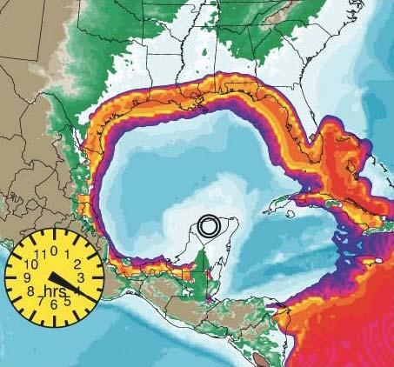
Fig. 37: The researchers modeled the asteroid impact believed to have led to the demise of the dinosaurs – this frame shows tsunami wave heights 4 hours after the impact of the 10-kilomtre-wide asteroid (Image: Steve Ward)Enlarge.

The Volcano Greenhouse Theory
The originator of the volcano-greenhouse theory is the American geologist Dewey McLean. He argued that the Deccan Traps main eruption of 65 million years ago in India coincided with the build-up of volcanic carbon dioxide in the atmosphere, triggering greenhouse climatic warming and a gradual, long-duration biological turnover. He pointed out that in the mass extinctions of 250 million years ago (the Permian (P) and Triassic (T) marine extinctions), coincides with the Siberian Traps volcanism in Siberia, one of the greatest episodes of flood basalt volcanism in Earth history.
McLean pointed out that there was a striking parallel between the P-T and the K-T extinctions with respect to environmental CO₂ build up. He reminds us that Earth is a greenhouse planet and argues that the greenhouse gases in the atmosphere, CO₂ and H₂O vapour, trap heat from the Sun, causing the Earth’s surface temperature to rise by 30 degrees Celsius above what it would be without them, allowing Earth to survive. In fact, without greenhouse warming, advanced life could not exist on Earth. Excessive variations in the greenhouse effect, however, can be dangerous to life. Greenhouse gases (CO₂ and H₂O) were trapped by the Earth when the Earth was a proto planet. Convection currents continually transport these gases to the surface by way of volcanoes and hot springs. Equilibrium between the release of these gases and their uptake can exist for a long time, but the sudden release of these gases in great quantities by volcanic activity can trigger ecological disaster and even mass extinction.

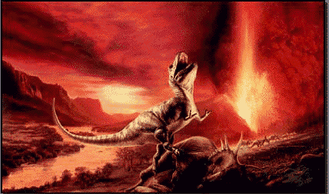
Fig. 38: The volcano-greenhouse theory of dinosaur extinction

Resolving the confrontation
Looking at the arguments and the interpretation of the evidence, it seems that the geological record generally is consistent with either theory. For example, both theories assume that clouds of dust and chemical changes in the atmosphere and oceans created an ecological domino effect that brought about the extinction of the dinosaurs and many species. The central issue, however, has been how rapid the event was. Did the mass extinction occur suddenly, or over many thousand of years? The impact theory calls for a very sudden ( a 100 years or less) extinction of the dinosaurs and the volcano-greenhouse theory allows times of thousands of years. Referring to the ongoing confrontation between the two theories Dewey Mclean has said:Some scientists, journalists, and popularizers of science claim that it has been proved that an asteroi , or comet impact has killed the dinosaurs. Such claims are premature and often political. The fact is that the K-T (and dinosaur) extinction debate is controversial in nearly every respect. ...In the mess of endless arguing, no one has proved what killed the dinosaurs in spite of claims one reads in science magazines, such as Science, some popular magazines , newspapers, and essays by popularizers of science who have never written a scientific paper on the K-T extinction, but have only seen it in fantastic TV videos. Walter Alvarez, on the other hand, is a little more willing to shake hands with the opposition when he says:
It seems possible that the impact triggered the Deccan Traps volcanism. A minute after a large body hit the Earth the initial crater would be 40 km deep, and the release of pressure might cause the hot rock of the underlying mantle to melt....The debate between the supporters of these hypotheses has become polarized: impact proponents have tended to ignore the Deccan Traps as irrelevant, while volcano backers have tried to explain away evidence for impact by suggesting that it is compatible with volcanism. Our sense is that the argument is a Hegelian one, with an impact thesis and a volcanic antithesis in search of a synthesis whose outlines are yet unclear.
Members of both groups, however, agree that chaotic events or catastrophes of the kind that triggered the extinction 65 million years ago must be seen as part of evolution, contrary to Darwin’s assumption of uniformitarianism in his Origin of Species of 1859. The October issue of 1990, Scientific American published two articles which brought the arguments of this confrontation to the public: An Extraterrestrial Impact, by Walter Alvarez and Frank Asaro, and A Volcanic Eruption, by Vincent Courtillot, a French geophysicist and defender of the volcano-greenhouse theory.
It is interesting to contemplate concluding remarks of these scientists:
As detectives attempting to unravel this 65 million-year-old mystery, we find ourselves pausing from time to time and reflecting that we owe our very existence as thinking beings to the impact that destroyed the dinosaurs. (W. Alverez and F. Asaro)
Events that at first seem to have been disasters may in fact have been agents essential in the evolution of complex life (V. Cortillot)
One wonders what Charles Darwin would say about the discovery that catastrophic events must be considered an important part of the theory of evolution. The American biologists Stephen J. Gould and Niles Eldridge the idea of “punctuated equilibria” being the mode in which the evolution of life forms mainly takesplace. The Australian geologist Duncan Steel suggests that, because of the advances of our understanding of importance of impacts from space, we should update the notion of “punctuated” and change it to “punctured”, the puncturing agents being asteroids and comets that visit us and often radically decide the direction of evolution.

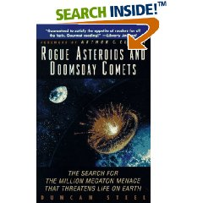
Fig. 39: “Rogue Asteroids and Doomsday Comets: The Search for the Million Megaton Menace That Threatens Life on Earth”, by Duncan Steel, (Highly recommended).

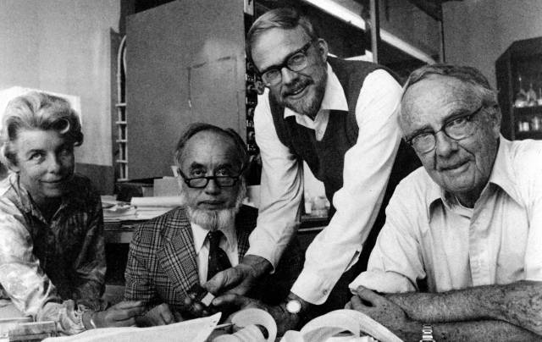
Fig. 40: Asteroid Impact research team (1969). Left to right: Helen Michel, Frank Asaro, Walter Alvarez and Luis Alvarez.

The Crash of ‘94: Jovian Fireworks
In July of 1994 a collision between a shattered, comet known as comet Shoemaker-Levy (S-L9), and Jupiter took place that graphically reminded us on Earth of the potential disaster of such events. The world witnessed the explosions created by the crash of 21 comet nuclei that were “strung out like pearls on a string”. On the Internet you can find a lot of interesting and detailed information about this cosmic occurrence which captured the imagination of the world. The event was televised in detail and presented in real time that raised the global consciousness and awareness of the “real” possibility of a cataclysmic impact on Earth.
After a series of miscalculations followed by a number of serendipitous happenings this impact was predicted and systematically observed and recorded. The initial observation of a close approach to Jupiter was made on March 18, 1993, and discovered on a photograph at a distance of approximately .38 Jupiter radii ( 71, 400 km) . The comet was in orbit around the Sun with a period of about 2 years and calculations show that it last made a close approach to Jupiter on July 7, 1992. Within about 2 hours after closest approach, the comet, presumably a single body at that time, was broken by the tidal forces of the large gravitational field of Jupiter into 21 pieces. The discernable pieces were designated with letters from A to W, with Q being the largest piece. Data were also (and are still) being returned by the spacecraft Galileo, which obtained direct images from a region that could not be viewed from Earth.

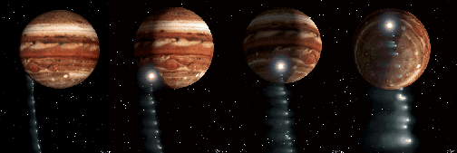
Fig. 41: The Shoemaker-Levy comet disintegrates and plunges into Jupiter in July 1992.

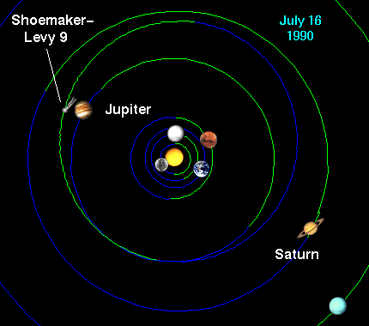
Fig. 42: The Shoemaker-Levy comet and Jupiter

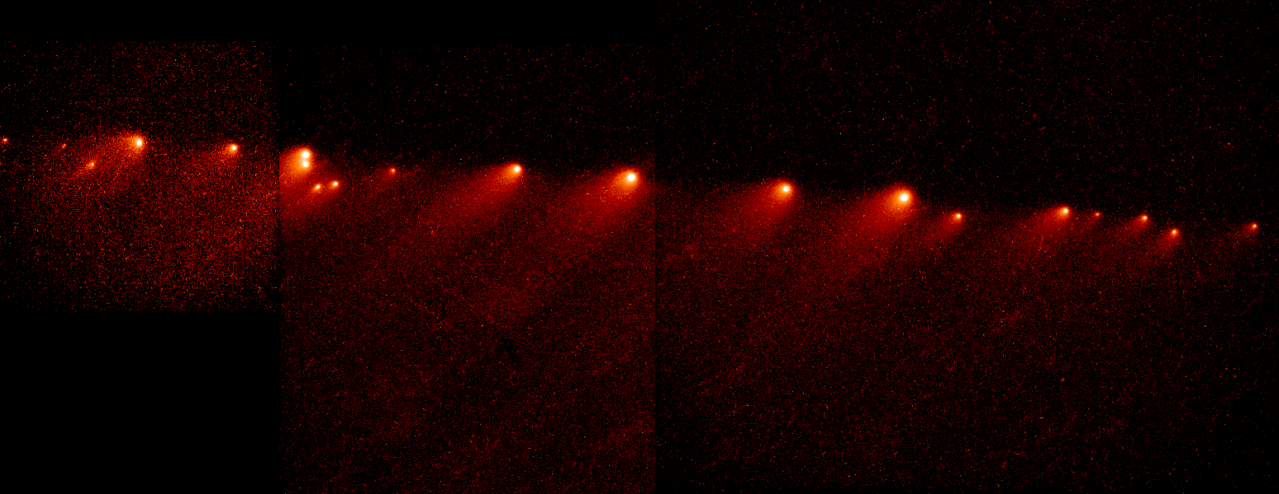

Fig43: The Shoemaker-Levy Comet Impact with Jupiter gave us a way to test theories of extinction by asteroid impact.

IL22 ***A video of the impact
http://www.google.ca/search?hl=en&q=.+The+Shoemaker-Levy+Comet+Impact+with+Jupiter&btnG=Google+Search&meta=
ILV7 **** A video of the impact
http://www.youtube.com/watch?v=7zNuT4dbdjU

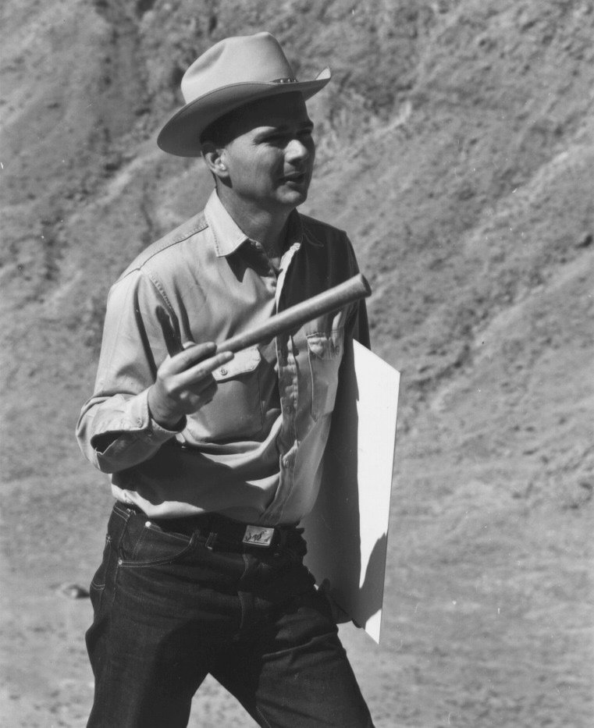

Fig. 44: Eugene Shoemeker, geologist (1928-1997).

Eugene Shoemaker, a geologist who shaped his science into a new form, astrogeology, and propelled it to the forefront in lunar and planetary exploration, was probably the 20th century's leading planetary scientist.

IL23 *** Biography of Eugene Shoemaker

http://www.agu.org/inside/awards/geneshoemkr.html

It was clear that the tidal stresses induced by the Jovian gravitational field caused the fragmentation and the chain discovered eight months later. Reviewing the events over a period of one year that lead to the final conclusion that an impact was inevitable, the astronomer Duncan Steel said:My main reason for discussing S-L9 is that the timetable of events surrounding its discovery and the prediction of impacts on Jupiter provide an exemplary lesson in what might happen should we find a body on a collision course with the Earth.NASA and the space agencies of other countries, shall identify and catalogue within 10 years the orbital characteristics of all comets and asteroids that are greater than 1 kilometer in diameter and are in orbit around the Sun and crosses the orbit of the Earth.

The data of the collisions of the “pearls” will provide material for research and model testing for planetary scientists for many years to come. Multiple impact events on Earth?

We have discussed in some detail the widely seen (on TV) 1994 collision between the fragmented large comet S-L 9 and Jupiter. We saw how the “Jovian Fireworks” forced astronomers to reinterpret the explanation of the black spots that astronomers seemed to have located on Jupiter periodically. This “new” phenomenon suggested to astronomers to look for similar occurrences on Earth. Recently, strong evidence has been found for the existence of crater chains on the surface of the Earth. A crater chain can be defined as an alignment of three or more impact craters, with the same apparent age, thought to be caused by the fragmentation and sequential collision of large bodies with the planet.

The geologists John Spray at the University of new Brunswick and his co-workers describe in the British science journal Nature, in Vol. 392, 1997.how they identified such a chain This chain consists of at least five craters, spread over approximately 4500 km, which were produced about 214 million years ago. You may have already identified these craters in the earlier section (Questions, Impact Craters). They are: Saint Martin (SM, Manitoba), Manicouagan (M, Quebec), Rochechouart (R, France), Obolon (O, Ukraine), and Red Wing (RW, U.S.).

Neither Manicouagan, nor Saint Martin is well exposed and were not discovered until quite recently. Saint Martin, just northwest of Winnipeg, Manitoba, was identified by gravity and magnetic surveys, in conjunction with a drilling program in the 1960s.

The researchers argue that the most recent radiometric and biostratigraphic age dating has placed these at about 214 million years, within experimental error. They found that each of the five structures:

a. shows features characteristic of hypervelocity impacts: shatter cones and impact- generated melt sheets.
b. has a clearly identifiable complex crater
c. is about 214 million years old.
Moreover, the research group has plotted these craters on a map of the ancient continent of Pangaea, showing the reconstructed positions of the North American and the Eurasian plates 214 million years ago. What they found was that the three large craters, SM, M, and R, plot as co-latitudinal at a mean latitude of 23 degrees. The spread in longitude is 44 degrees, about 4500 km.
The researchers’ conclusions can be summarized this way:
a. At the least the three large craters were generated by the fragments of shattered bolide that were, like the S-L 9 fragments, coaxial to each other.
b. The fact that the craters lie at a constant latitude indicates that the fragmented body that produced them had been captured in an Earth orbit.
c. The distance between craters gives the angle through which the Earth rotated between impacts
d. There may have been more than five impact structures involved.
e. The probability of the three co-latitudinal structures being caused by a random event is extremely low.
There are several hypotheses that try to account for the occurrence of crater chains on Earth:
Hypothesis I: Double or multiple craters could be accounted for by the impact of some asteroids mutually orbiting one another.
Hypothesis II: The earth may have been struck by a comet nucleus that was already in the process of breaking up on entering the Earth’s atmosphere.
Hypothesis III: Gene Shoemaker proposed a long time ago that a comet may break up in a flyby around Jupiter

Assessing the risk
We face two significant problems when trying to assess the risk of impact by celestial bodies. One is our ignorance of the orbits of the vast majority of them and the other the interpretation of the probability calculations. About 100,000 tons of space materials collide with the Earth each year, 40 % of this as dust and the rest as larger chunks of meteors. The occasional hit by large meteors (50m-100m), like the Barringer impact, and especially the huge ones (100 km) like the Yucatan impact, of course, dominate the long-term mass influx estimate.

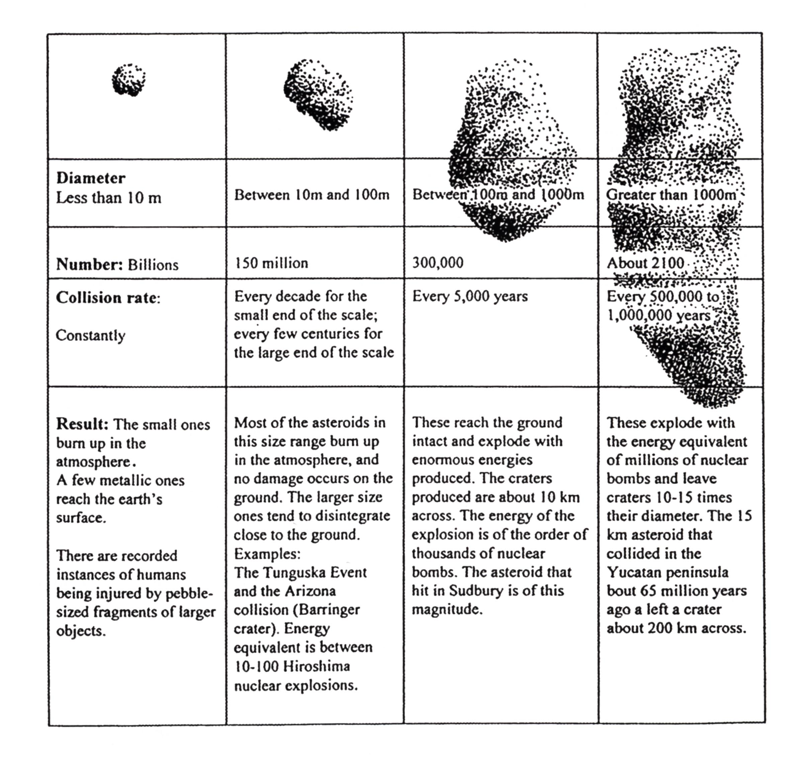
Fig. 45: Collision dynamics for different sizes of bolides.

We now know of about 160 Earth-crossing asteroids, although many have poorly determined orbits and have been lost again. About half of these are 1 km across or larger. Only since 1990 when the excellent telescopic camera of Spacewatch at the University of Arizona has been operating, can we routinely detect asteroids of the size of 10-100 m across. Still, according to the best estimates, about 15% of the total population of Earth-crossing asteroids down to 2 km size is known and only about 7% of the 1-2 km bodies have been found. When you think of a smallish (50-100m across) meteorite, like the one that hit Arizona, you realize that it is important to know the orbits of all of them that are larger than 1km.
The second problem with risk assessment is illustrated in a story told recently by the Australian astronomer and asteroid expert, Duncan Steel:
One particularly impressive meteoroid entry happened on April 9, 1993, when a “fireball” was seen by hundreds of people over the south coast of New South Wales. It generated great excitement and I told the media that such an event might be seen from any one spot only once in a decade, ...if you stayed up all night, every night, and kept your eyes open. It was therefore a source of great embarrassment when precisely a week later, an even bigger meteorite - estimated at 3-4 meters in size crossed the sky as it turned night into day for a few seconds ...The shock generated was felt in a radius of at least 100 km. ..It seems that many of the people in the town of Dubbo (30,000 inhabitants) were hiding under their beds and the state police were alerted as houses were shaken to their foundations and windows were shattered.
You have done several calculations on the energy of a very high speed mass, so it shouldn’t come as a surprise that the energy of this boulder was equivalent to a small Hiroshima-type nuclear bomb. Fortunately, the bolide exploded at about 18 km in the atmosphere. We are reminded of the Tunguska event. The lesson of this story is that “future events are not effected by past events” even if probability calculations suggest otherwise.
The calculations in the table below summarize the different categories of comets and asteroids and their diverse characteristics of orbit. There are two basic types of Earth-crossing asteroid, the Atens, and the Apollos. The Atens have an orbital period of less than one year and the Apollos greater than one year. There are three types of comets that we must consider short period comets, intermediate-period comets, and long-period comets:
Short-period comets are those with periods of less that 20 years (P/Hartlly 2); intermediate-period comets are those with periods between 20 and 200 years (Halley’s comet), and long period comets (Machholz, 1985 VIII) have periods longer than 200 years. These long-period comets are sometimes in a parabolic orbit, and only pass by once.

Fig. 46: Atens, Apollo asteroids and Earth-crossing comets

If we take P and divide by T (P/T) we get the impact probability per year. Notice that the P/T is the highest for Atens asteroids.
Also note that no period is appropriate for parabolic comets because they generally pass through the planetary region once and are never seen again.
But what about the smaller Earth-crossing asteroids? Can we estimate how many there are? One way to understand how such estimates are made is to imagine picking up pebbles on a beach. The pebbles you pick up follows a power-law distribution: the number of a given size you pick up is proportional to the inverse of the square of the size involved. The results of calculations based on this law leads to the following estimate of the populations of smaller Earth crossers:
Larger than1 kilometer: 2000 (between 1000 and 3000)
Larger than 500 meters: 10,000 (between 5000 and 2000)
Larger than 100 meters: 300,000 (between 150,000 and 1 million)
Larger than 10 meters: 150 million (between 10 and 1000 million)
Objets smaller than 10 meters enter the atmosphere about once a year, but are of little concern because most of them will burn up in the atmosphere. These collisions are observed as very bright fireballs and can be a frightening experience for people close to the collision.

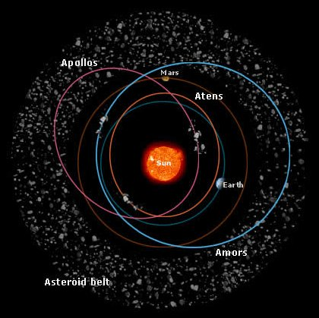
Fig. 47: Atens, Apollo asteroids and Earth-crossing comets.

Some Apollo objects can approach closer than Mercury to the Sun, the record-holder being 1995CR with a perihelion distance of 0.12 AU. Other notable members of the group include (1862) Apollo (the prototype), (1866) Sisyphus (the largest, with a diameter of about 8 km), (3200) Phaethon,(1685)Toro, and (4179) Toutatis.

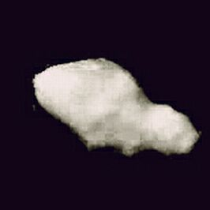
Fig. 48: Tautatis, One of the largest near-Earth asteroids and potentially one of the most dangerous.

A member of the Apollo group, it was discovered in 1989 by French astronomers and named (somewhat inappropriately) after a Celtic god that was the protector of the tribe in ancient Gaul. Its eccentric, four-year orbit extends from just inside Earth’s orbit to the main asteroid belt.

The danger comes from the fact that the plane of Toutatis’s orbit is closer to the plane of Earth's orbit than any known Earth-crossing asteroid. In December 1992, Toutatis came within about 4 million km of Earth enabling radar images to be acquired. These images revealed two irregularly shaped, cratered objects about 4 and 2.5 km in average diameter which are probably in contact with each other.

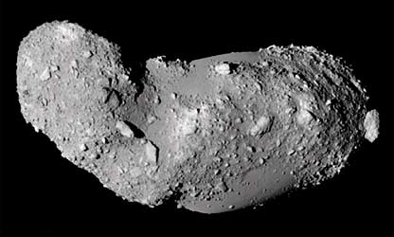
Fig. 49: An Apollo asteroid which crosses the orbit of Mars and comes near the Earth. It was discovered on September 26th 1998 and named after Hideo Itokawa (1912-1999) a Japanese rocket scientist

Questions and Problems
Size distribution of asteroids follows a power law:
N ~ R^{x}
where N is number of impacts per year, R is the radius of the asteroid, and x is the power index. Using the graph below write the formula:
N = k R^{x.}
Find the value of x and k. What are the units of K?

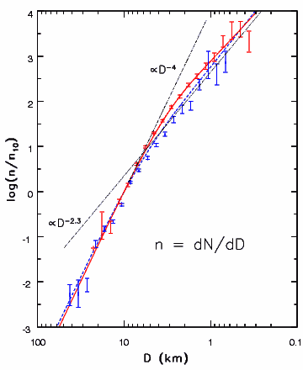
Fig. 50: The power law of asteroid distribution. The differential size distribution of Main Belt asteroids normalized by its value for D=10 km. The solid and dashed lines for analytic estimates, and error bars for nonparametric estimates, are for red (rocky) and blue (carbonaceous) asteroids respectively. The dot-dashed lines are added to guide the eye and correspond to power-law size distributions with indices 4 and 2.3. Image credit: Tom Quinn and Zeljko Ivezic, SDSS Collaboratio

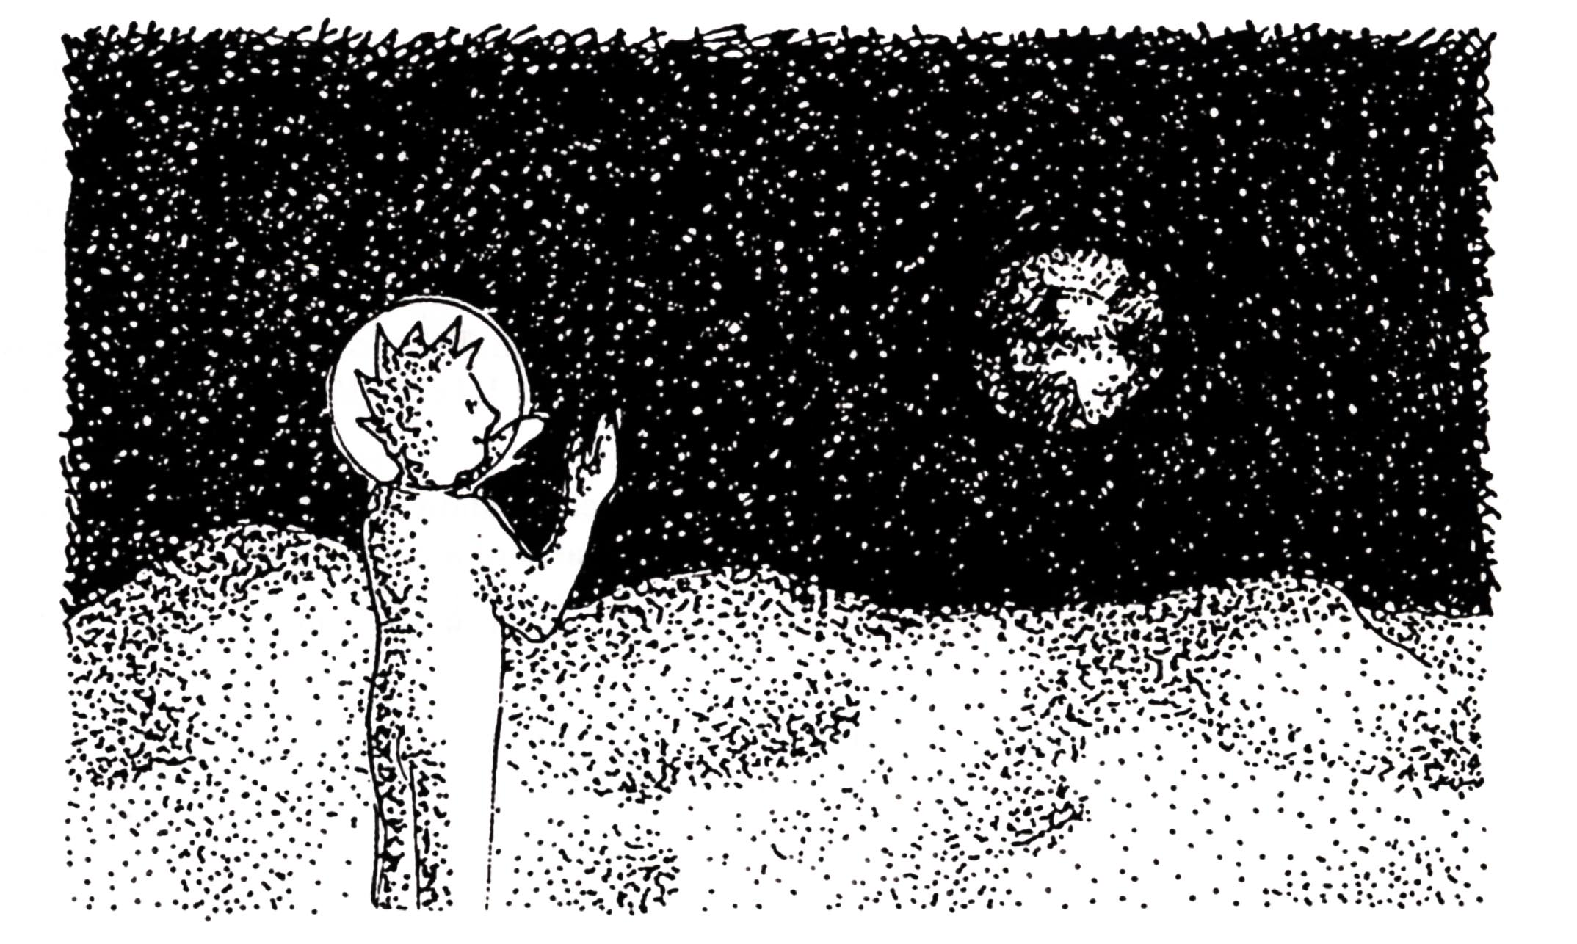
Fig. 51: Earth as seen on the asteroid Toutatis

Toutatis, a rogue asteroid
In 1989, asteroid 4179 was discovered by French astronomers and named Toutatis, after a Celtic god that was the protector of the tribe of Gaul. Its eccentric four-year orbit extends from just inside the Earth’s orbit to the main asteroid belt. Toutatis made a close approach to Earth in December, 1994. The distance of close approach was about 4 million kilometers. Radar images of Toutatis reveal two irregularly shaped and cratered objects, one about 4 kilometers and the other about 2.5 kilometers across. Toutatis is one of two “contact binaries” known. The other one is Castalia was observed in 1989 when it passed near the Earth. The numerous craters on Toutatis (one of them almost one kilometer across) strongly suggest that it has had a complex history of impacts. Toutatis is an eccentric Earth-crossing asteroid in an orbit that moves it from the asteroid belt between Mars and Jupiter to just inside the Earth’s orbit. It is tumbling through space in an irregular way and will have a close encounter with Earth on September 29. 2004 when it will come within 1.5 million kilometers, or about 4 times the distance to the Moon. This is the closest approach predicted for a known asteroid before 2060. Studying the near-Earth asteroids such as Toutatis helps astronomers find the connections between meteorites, main-belt asteroids, and comets.
Planets and the vast majority of asteroid spin about a single axis like football thrown in a perfect spiral. Toutatatis, however, tumbles like a “flubbed path”, said astronomer Scott Hutton, an expert on Toutanis, in a recent interview. The rotation of Toutanis is determined by two motions, spin and a tumbling. Its “North pole” wanders along a curve on the asteroid about every 5.4 years while it also spins regularly about a well defined axis every 7.3 days. The orbit of Toutatis is extremely chaotic. Responding to a paper in the journal Icarus in which the authors of an article (“Long-term dynamical evolution of the minor planet Toutatis”, 1993) claim that Toutatis’ orbit is extremely chaotic, the astronomer Scott Hutten said:
this means that small uncertainties in the orbit quickly get amplified by close Earth approaches. The effect is similar to the scattering of billiard balls on a pool table. In principle this is perfectly predictable, but small uncertainties are greatly amplified by each collision. Discussions with members of the Solar System Dynamics group at JPL seem to support the view that it is difficult to accurately predict the the orbits of close Earth approaches more than a few centuries into the future.

Problems:
1. The two distinct parts of Toutatis may be connected in a very small neck. Imagine that neck holding together the two parts, one about 2.5 km across and the other about 4 km.
a. Estimate the gravitational force where contact this made.
b. Consider the tumbling action of Toutatis. How, and at what rate would the asteroid have to tumble so that the two rocks would overcome their gravitational attraction? Discuss.
2. The estimated mass, “radius” and rotational speeds of the planets and asteroids given below. Complete the table as indicated and then answer the questions below:
a. Calculate the bulk density
b. The surface gravity
c. The centripetal acceleration due the planet’s or asteroid’s rotation
d. The escape velocity from the planet
e. The period of a 25 cm pendulum on the surface of the planet or asteroid

Comment on these values and discuss some of the implications for space travel. For example: is it possible to land on Icarus considering the neutralizing effect of the “centrifugal” force on the gravity?

Questions
1. Many astronomers believe that some of the Earth-crossing asteroids are actually extinct or dormant comets.
a. What do astronomers understand by extinct or dormant here?
b. There are many examples of such comet/asteroid transformations on the Internet and the references. Find one and give details.
2. Many astronomers believe that a clear distinction between asteroids and comets cannot be made. Do a little research and comment.
3. Imagine landing on a wildly tumbling asteroid like Toutanis for the purpose of mining activities. How would you manage to settle down on the surface, place solar collectors and establish a direction? Discuss.
4. If the two large rocks are really “contact binaries”, that is, are held together by gravity, how do you suppose they got that way?

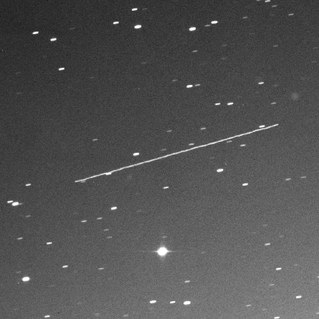
Fig. 52: The discovery of Toutatis

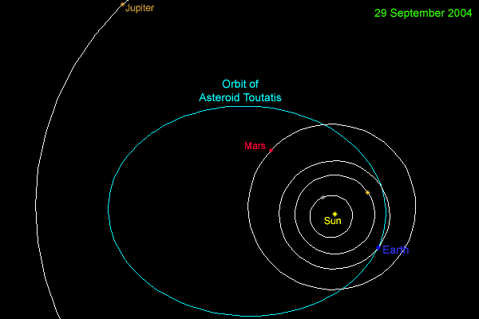
Fig. 53: The orbit of Toutatis

Special Problem:
Find a trajectory to Toutatis using the HOT trajectory method. What would be the total time it takes to go there for a mining expedition that lasts one month on the asteroid.

Specifics for asteroid Toutatis
Size | 4.5 × 2.4 × 1.9 km
Density | 2.1 g/cm³
Spectral class | S
Rotational periods | 5.41 and 7.35 days
Semimajor axis | 2.516 AU
Perihelion | 0.92 AU
Aphelion | 4.11 AU
Inclination | 0.5°
Period | 4 years
Asteroid and comet collisions have become a popular topic in the 1990s. Public awareness of the potential for a collision with a rogue asteroid or a comet was raised because of several recent occurrences that were all highly publicised. Many things have contributed to a more collective and political awareness of the dangers of asteroid collisions: from the Alvarez’ team promotion of the “dinosaur extinction by impact”, the reports of a “near miss” by 1889 FC asteroid, the Jovian impact of SL-9.that could be watched on TV in real time, to the premature announcement that the Asteroid 1997XF11 was on a collision course with Earth in 2028. Clearly, the movies Armageddon and Deep Impact have also contributed to capturing the imagination and the concern of the general public. As early as 1990 the U.S. House of Representatives, in its NASA Multiyear Authorization Act stated in part:
The Committee believes that it is imperative that the detection rate of Earth-orbit-crossing asteroids must be increased substantially, and that the means to destroy or alter the orbits of asteroids when they threaten collision should be defined and agreed upon internationally.
Spacewatch is the name of a group at the University of Arizona/s Lunar and Planetary Laboratory (LPL)
The primary goal of this group is
.... the study of statistics of comets and asteroids in order to investigate the collisional evolution of the solar system’ the discovery of target asteroids for space missions, such as Clementine, whose aim is the exploration and the protection the Earth from asteroid impact.
The Spacewatch program was the result of action taken by Congress in the US that asked for national workshops in 1990. The astronomer and asteroid expert, Tom Gehrels, of the University of Arizona, started systematically looking for asteroids using a special telescope, using the newly developed CCD’s (charge-coupled devices) which are superior to photographic emulsions.
WHERE DOES THIS TEXT COME FROM?
spin and tumble so that it would be impossible to attach a sail. The second one, however, seems possible. They showed that a sail of 0.5 km in diameter could deflect an asteroid up to 2 km in size, assuming continuous operation for a year. The reflective material would only have a mass of about one ton. Already in 1967 there were groups of scientists concerned about a possible asteroid collision with the Earth. At MIT a group of engineering students was given the problem of diverting the asteroid Icarus, which was imagined to be on a collision course with Earth. The conclusion of the students was that the asteroid could be diverted by using a Saturn V heavy-lift capability (then available for the Apollo program) and six 100 megaton hydrogen bombs. The scenario was based on the assumption that there was only about a year left before impact, and that meant high velocity changes were required.
Note: LCP 11 Part II contains:
Spacewatch
Deflection calculations
Asteroid and comets in the media
Impact Craters on Earth
Jupiter and the mystery comet Lexell

Playing “orbital billiards: Capturing of the payload by using several Moon flybys
 | 1 | 2 | 3 | 4 | 5 | 6 | 7 | 8 | 9 | 10 | 11 | 12 | 13
A | Stone
B | Angle | Length | Density | velocity | Area | Q | Energy | Mass | g | C_{d} | C_{h} | Yield Strength | Time
C | degrees | m | kg/m³ | m/s | m² | J/kg | J | kg | N/kg |  |  | N/m² | s
D
E | 45 | 100 | 3.50 x 10³ | 15000 | L² | 8.00 x 10⁶ | ½mv² | D x L³ | 9.6 | 1.5 | 0.1 | 1 x 10⁷ | L/2000
F
G |  | . |  |  |  |  |  |  |  | .
H | Altitude | density | average | velocity | Drag | Mass loss | time | mass | Weight | Total Force | acceleration | pressure | Alt
I | km | of air | density |  | F_{drag} | Rate (mR) |  |  | F_{g}sin | F_{total}
J |  | kg/m³ | kg/m³ | m/s | N | kg/s | s | kg | N | N | m/s^2 | N/m² | km
K
L | 100 | 1.00 x 10⁶ |  | 1.50 x 10⁴ |  |  |  | 3.50 x 10⁹ | 2.38 x 10¹⁰ | 2.38 x 10¹⁰ | 9.6
M | 90 | 3.00 x 10⁶ | 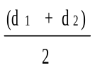 | 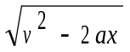 | 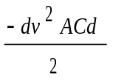 | 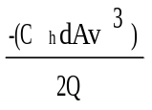 | 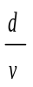 | 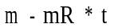 | 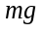 | F_{drag} + F_{g}sin | 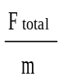 | 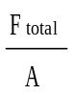 | 95
 | 100 m
N | 100 | 1.00 x 10⁶ |  | 1.50 x 10⁴ |  |  |  | 3.50 x 10⁹ | 2.38 x 10¹⁰ | 2.38 x 10¹⁰ | 9.6
O | 90 | 3.00 x 10⁶ | 2.00 x 10⁶ | 1.50 x 10⁴ | -1.27 x 10⁶ | 4.22 x 10² | 0.94 | 3.50 x 10⁹ | 2.38 x 10¹⁰ | 2.38 x 10¹⁰ | 6.79 | 6.34 x 10¹ | 95
P
Q | 10 | 4.14 x 10⁻¹ | 3.90 x 10⁻¹ | 1.50 x 10⁴ | -1.76 x 10¹¹ | 8.28 x 10⁷ | 0.09 | 3.43 x 10⁹ | 2.34 x 10¹⁰ | -1.52 x 10¹¹ | -4.42 x 10¹ | 8.78 x 10⁶ | 10.5
R | 9 | 4.67 x 10⁻¹ | 4.41 x 10⁻¹ | 1.50 x 10⁴ | -1.98 x 10¹¹ | 9.36 x 10⁷ | 0.09 | 3.42 x 10⁹ | 2.33 x 10¹⁰ | -1.75 x 10¹¹ | -5.08 x 10¹ | 9.90 x 10⁶ | 9.5
S | 8 | 5.26 x 10⁻¹ | 4.96 x 10⁻¹ | 1.50 x 10⁴ | -2.23 x 10¹¹ | 1.05 x 10⁸ | 0.09 | 3.41 x 10⁹ | 2.32 x 10¹⁰ | -1.99 x 10¹¹ | -5.82 x 10¹ | 1.11 x 10⁷ | 8.5
 | 1 m stone
T | 100 | 1.00 x 10⁶ |  | 1.50 x 10⁴ |  |  |  | 3.50 x 10³ | 2.38 x 10⁴ | 2.38 x 10⁴ | 9.60
U | 90 | 3.00 x 10⁶ | 2.00 x 10⁶ | 1.50 x 10⁴ | -1.27 x 10² | 4.22 x 10⁻² | 0.94 | 3.50 x 10³ | 2.38 x 10⁴ | 2.36 x 10⁴ | 6.75 | 6.34 x 10¹ | 95.0

V | 15 | 1.95 x 10⁻¹ | 1.42 x 10⁻¹ | 1.38 x 10⁴ | -7.00 x 10⁶ | 2.55 x 10³ | 0.50 | 1.03 x 10³ | 7.02 x 10³ | -6.99 x 10⁶ | -6.76 x 10³ | 3.50 x 10⁶ | 17.5
W | 11 | 3.65 x 10⁻¹ | 2.80 x 10⁻¹ | 1.07 x 10⁴ | -7.88 x 10⁶ | 3.24 x 10³ | 0.46 | 0.00 | 0.00 | -7.88 x 10⁶ | Burned | 3.94 x 10⁶ | 13.0
X | 10 | 4.14 x 10⁻¹ | 3.90 x 10⁻¹ | 1.07 x 10⁴ | -8.94 x 10⁶ | 3.01 x 10³ | 0.13 | 0.00 | 0.00 | -8.94 x 10⁶ | Burned | 4.47 x 10⁶ | 10.5
Table I. Spreadsheet Examples

